Creative State Global City

Creative industries taskforce report November 2015

Table of contents
Creative Industries Taskforce message 4
Executive Summary 5
- The significance of the cultural and creative industries 10
  - Cultural and creative industries in a global context 10
  - The Victorian cultural and creative economy 14
  - Opportunities for Victoria 18
  - Challenges for Victoria 21
- The response: Creative State Global City 24
  - Overview 24
  - Benefits of making Victoria a creative state
and Melbourne a global city 26
  - Focus areas 27
- Action and implementation 34
  - Backing creative talent 35
  - Strengthening the creative industries ecology 36
  - Delivering wider economic and social benefits 38
  - Increasing participation and access 39
  - Building international engagement 40
Appendices 42
Appendix A: Expert Reference Group members 42
Appendix B: Taskforce Terms of Reference 42

strategy.creative.vic.gov.au 3

Creative Industries Taskforce message

Executive Summary

In 2014, the Victorian Government announced it would develop Victoria’s first creative industries strategy to increase the cultural, social and economic impact of Victoria’s cultural and creative industries. This intention was reinforced
by the establishment of a new government agency, Creative Victoria.

Cultural and creative industries are among Victoria’s fastest growing industries. They are at the heart of the State’s liveability, global profile and economic future. Cultural and creative industries have a major influence on the character of Melbourne and Victoria, affecting every Victorian citizen in some way. They contribute culturally, socially and economically. Vibrant cultural and creative industries have enormous transformative power. In fact, the future of many of Victoria’s major industries will depend on how well we can apply and realise benefits from creativity, whether in international education, agriculture, advanced manufacturing or the services economy. Put simply, Victoria’s future is dependent on the cultural and creative industries.
In April 2015, the Minister for Creative Industries, Martin Foley MP, appointed the Creative Industries Taskforce to advise and produce a report on the development of a creative industries strategy. Our Taskforce comprised people with a diverse mix of skills and experience across different cultural and creative industry sectors, business and government. It comprised the following members:
• Louise Adler AM (Chair): CEO, Melbourne University Publishing
• Dr Bronte Adams: Director, dandolopartners
• Tony Ayres: Producer/Director, Matchbox Pictures
• Mark Madden: Director, Devil’s Advocate
• Shaun Micallef: actor, comedian and writer
• Professor Callum Morton: artist and academic
• Eddie Perfect: writer, actor, singer-songwriter
• Karen Quinlan: Director, Bendigo Art Gallery
• Dan Rosen: CEO, Australian Recording Industry Association
• Katrina Sedgwick: Director/CEO, Australian Centre for the Moving Image.
An Expert Reference Group, representing a wide range of disciplines, provided us with invaluable advice and ideas. A full list of Reference Group members can be found at Appendix A. In addition, the Taskforce consulted broadly to ensure that this report and the Government’s subsequent strategy are built from

Minister for Creative Industries Martin Foley MP and the Creative Industries Taskforce L-R: Shaun Micallef, Mark Madden, Louise Adler, Tony Ayres, Martin Foley MP,
Callum Morton, Bronte Adams, Katrina Sedgwick, Dan Rosen, Karen Quinlan,
Eddie Perfect (absent)

the ground up, not the top down. The nature of Victoria’s cultural and creative industries has changed over time and the consultation process was designed to capture new perspectives from emerging as well as established fields. The consultation process was extensive, capturing contributions from thousands of people
and organisations in face-to-face and online forums.*
The Taskforce is grateful to the cultural and creative sectors – and to the public, more generally – for the enthusiastic response, and for the rich volume of information and insight that was provided. Victorians told us clearly the value they see in Victoria’s cultural and creative industries, and how they can be strengthened. A consistent message from Victorians was that our cultural and creative industries have great strengths and that our strategy should be bold and decisive. They told us that the strategy has to be ‘action-oriented’ not ‘rhetoric-laden’.
To this end, we are now pleased to present our report. Fundamental to the report is the vision that Victoria is a creative state and that Melbourne is a truly global as well as liveable city. The Taskforce considers that these aspirations are suited to Victoria’s distinctive strengths and the potential of its creative practitioners and businesses, and that they provide an ambitious and flexible foundation for future action.
From the suggestions and advice of all those who have contributed to the process, the Taskforce has formulated 42 initiatives for the Government to consider. This plan aims to ensure Victoria retains and grows its leading role in the cultural and creative industries in an increasingly globalised and disrupted world. The opportunity is ours to grasp.
We have the talent and the human capital. We need the political will to unlock, promote and champion our creativity on local, national and global stages. The Taskforce is pleased to present it’s report, Creative State Global City.

Cultural and creative industries are critical to the State’s future.
The cultural and creative industries include disciplines as diverse as digital games development and graphic design, fashion and filmmaking, performing arts and publishing, architecture, music, comedy, visual arts and craft. They comprise a mix of artistic and non-artistic sectors, not-for- profit and community organisations, individual practitioners, commercially driven businesses and cultural institutions.
Cultural and creative industries define the cultural landscape of the State and give it a brand, personality and profile that can be readily recognised, enjoyed and promoted. As is the case for many places, Victoria’s identity owes its evolution and uniqueness to the ideas and expressions of its cultural and creative industries and the responses they stimulate.
In addition, the cultural and creative industries have major economic and social impacts. Victoria is a knowledge and services-based economy. Unlike other Australian states, Victoria cannot rely on large reserves of natural resources to sustain growth. Instead, it must look to creativity and innovation for future growth, which are the very skills and capabilities on which the cultural and creative industries are based. Creative industries encompass and underpin large and fast-growing sectors that are set to overtake previous Victorian industry successes, such as manufacturing. Employment in creative sectors is resilient because creative jobs are harder to automate or shift overseas, where labour costs might be cheaper.
The impact of Victoria’s cultural and creative economy is already significant. In 2013, it accounted for 8% of the State’s economy, employed more than 220,000 people, and contributed $22.7 billion in gross value add. Arts and culture are a fundamental drawcard to Victoria’s visitor economy, with cultural tourism generating $1 billion for the State in 2013.
Critically, cultural and creative industries are important and often undervalued contributors to society and social
outcomes in a wide variety of spheres. Effective applications of creativity have the potential to drive not only economic but social benefits.
The distinctive and important cultural contribution of the cultural and creative industries is well understood.
The establishment of a creative industries portfolio is the opportunity for cultural and creative industries to also take their rightful place as part of the economic mainstream and as a significant contributor to social policy. The magnitude and reach of their impact will depend on how well challenges can be overcome.

Victoria must capitalise on its acknowledged strengths in arts and culture.
Victoria’s long-established strengths in arts and culture come from all sizes of business, from individual practitioners and small to medium organisations, to major organisations and institutions. Victoria is the national leader in visual and performing arts and home to leading libraries, galleries and museums. It hosts myriad festivals and dynamic literary and live music scenes. It also has Australia’s only Centre for the Moving Image; Centre for Books, Writing and Ideas; and the nation’s premier arts training institutions.
Australia’s Aboriginal and Torres Strait Islander community is recognised as one of the oldest continuing living cultures in the world. Victorian Indigenous art is represented in respected Australian (and international) historical and contemporary art collections. The Koorie Heritage Trust houses a unique collection dedicated solely to the art and material culture of Victorian Indigenous communities.
Victoria also has a strong tradition in design and recognised strengths in architecture, web and communications design, fashion and industrial design. The major design universities have outstanding research facilities and infrastructure, and an increasing international footprint. Half of Australia’s digital games sector is based in Victoria, as is a third of the
broader screen industry. Over half of national television drama production is undertaken in the State.
Melbourne is rightly recognised as Australia’s cultural capital. It has been independently rated the world’s most liveable city five years running. It enjoys a well-recognised international brand as well as sister-city relationships with Osaka, Tianjin, Boston and Milan. In 2015, Victoria signed a cultural memorandum of understanding with China that sets the framework for future trade and cultural exchange, providing new opportunities for Victorian artists and creative organisations.

* A consultation summary report is available at strategy.creative.vic.gov.au
- Creative and cultural industries strategy strategy.creative.vic.gov.au 5

executive summary

Victoria is competing with the world in terms of attracting, building and applying creativity.
Many countries recognise the importance of culture and creativity as drivers of economic advantage and social advancement. They have invested financially, strategically and in a sustained manner. They are pro-active about capturing the broadest range of benefits possible, understanding that measures of social wellbeing also correlate, to varying degrees, with the vitality and strength of the cultural and creative industries.
Victoria faces global competition in attracting and retaining creative talent and businesses. It competes with neighbours, such as Singapore and New Zealand and with countries further afield, like Canada and the United Kingdom, which have recognised the value of their creative industries and supported them with dedicated policies.

Victoria must address current challenges if it is to thrive on the global stage.
Opportunities to participate and benefit from Victoria’s cultural and creative industries are not equitable.
Victoria cannot claim that its population has adequate or equitable engagement with arts and cultural experiences.
Its regions and outer metropolitan areas are not as well serviced as Melbourne. The State’s Indigenous and multicultural populations are under-represented in creative employment, product and participation. Employees, creative practitioners and audiences with a disability face unacceptably high barriers to access. Demand for art in public and community spaces is not being met.
The potential of creativity and culture is not adequately understood early in life, and pathways into sustainable creative work are weak.
It is critical to build stronger interest in culture and creativity at a young age. But that alone is not enough. Victoria currently has significant room for improvement in terms of the pathways between school education, tertiary study and creative careers. Currently these pathways are difficult to find and to follow, and employment outcomes for arts graduates are relatively poor. For individual practitioners, the development of creative and artistic practice can be slow and fraught. Most cannot live on their creative work alone: the personal investment is invariably high; the rewards are uncertain; and many don’t have enough time, funding or the right skills to create an effective business model to sustain or expand their work. In some areas such as book publishing, film and music, practitioners must also deal
with the changing competitive landscape and disruption driven by technology.
International links could be better developed.
Victoria must deepen its international reach. The State has established relationships with the United Kingdom, Europe and the United States but the closer growing markets in Asia have enormous and relatively untapped potential.
The benefits of exposure in these markets will more than compensate the difficulties involved in building the necessary relationships and trade.
The lack of a clear policy focus has stifled innovation and created uncertainty.
Victoria can genuinely claim leadership in many areas of cultural and creative endeavor despite the fact that it has been without a strong policy in the arts for a number of years. Some foundational elements of our cultural and creative offerings – from festivals to design strategy – are in need of renovation. In the meantime, other places in Australia and around the world have been active.

Victoria should be optimistic about the role creativity can play in its future, and government has a clear role.
Victoria should be ambitious about the future. Victoria has the raw ingredients to be a genuinely creative state, with the ability to transform Melbourne into a truly global city. To do so
will require significant focus and investment in vibrant creative practitioners, iconic cultural infrastructure and assets, thriving cultural and creative businesses, deep and broad community engagement, audiences, access and an international outlook.
The most effective role for government is to strengthen the overall ecosystem within which creative practice takes place.
For this reason, the Taskforce proposes initiatives that aim to strengthen the entire cultural and creative ecosystem and all the sectors within it. They are generally not targeted at particular sub-sectors but, instead, to issues, barriers and circumstances that span them all. An effective ecosystem will provide adequate and affordable spaces for creative practitioners to work, individually or together. It will improve access to business skills and finance, which for many are currently out of reach. It will build a more comprehensive appreciation of the social benefits of creative services as well as the economic advantages. Government can help with many of these, but its intervention and more public funding do not provide the whole answer.

Our vision is ambitious and is supported by a proposed strategy and 42 initiatives.
The vision is for Victoria to build on its credentials as a creative state, with Melbourne as a truly global as well as liveable city.
Our view is that while Victoria has committed to development of a creative industries strategy, it should not reproduce other models. The most effective strategy will take into account Victoria’s unique assets, capabilities, culture and history.
It should address the gaps and challenges that Victoria faces and it should deliver the benefits that Victoria most needs.
Achieving this vision depends on the extent to which:
- Victoria has a vibrant, rich, innovative cultural and creative sector
- There is a thriving creative ecology and businesses
- Creativity is applied to add value across industry, education and public services
- Arts and creativity are valued by the local community
- Strong international engagement is ubiquitous.
These outcomes are the hallmarks of global cities and creative states. The Taskforce proposes five focus areas that require seizing specific opportunities, drawing on established strengths and addressing specific challenges. The focus areas target particular areas but also contribute to achieving all the outcomes in different ways and to varying degrees. They are:
- Backing creative talent by creating more opportunities to produce and present great work
- Strengthening the creative industries ecology by building capacity and unlocking opportunities to reach audiences and markets
- Delivering wider economic and social benefits through the application of creativity and using Creative Victoria as a force for collaboration
- Increasing participation and access by setting high standards for education, access and public events and broadly promoting the value of art and creativity
- Building international engagement by positioning creative industries in the economic mainstream in addition to their already recognised cultural role.
The overall framework, illustrating the relationship between the vision, outcomes and focus areas, appears on the next page.

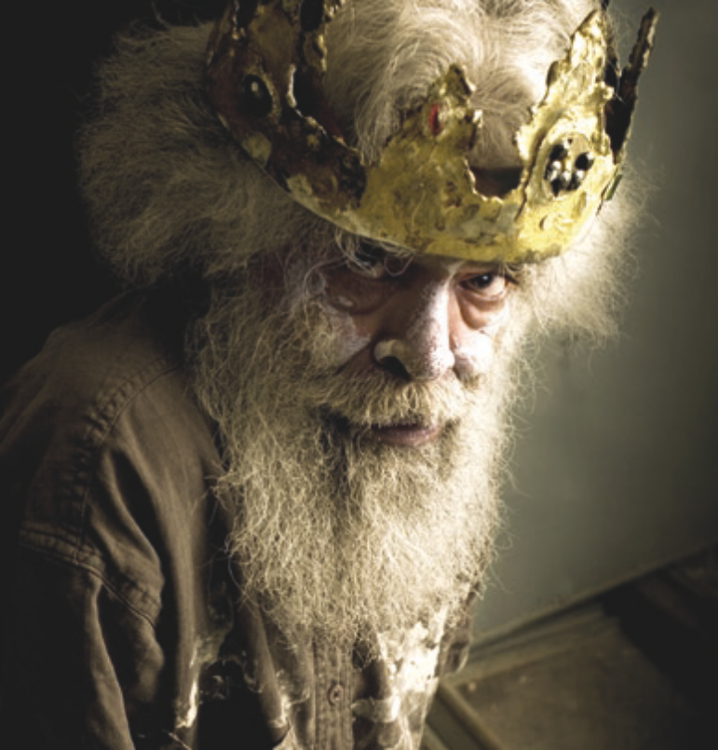Ilbijerri Theatre Company, Jack Charles V The Crown (2011). Credit: Bindi Cole

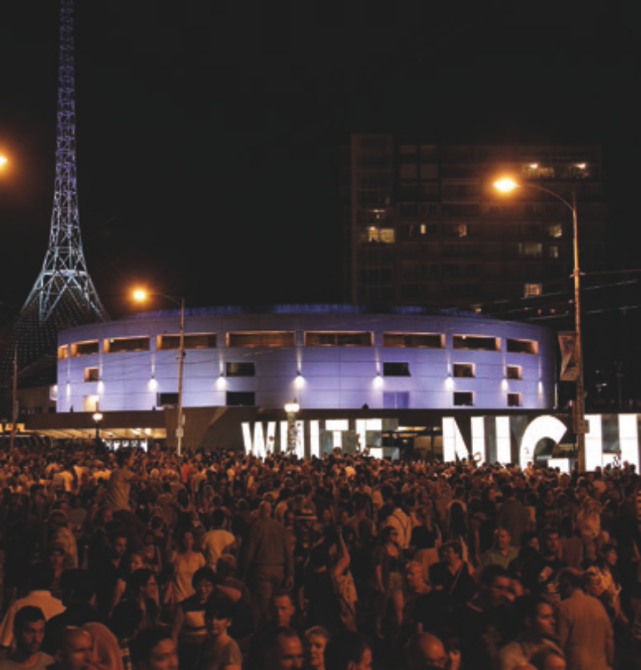White Night Melbourne (2013). Credit: Courtesy of Tourism Victoria

executive summary

Creative state

What’s required to make Victoria a Creative State and Melbourne a Global City?

The Taskforce recognises that the development of a strategy is only the first step. The Government will need to consider the proposed initiatives – many of them with implications for additional funding.

aspiration

The cultural and creative industries make Victoria a creative State and Melbourne a global as well as liveable city
With a new agency in Creative Victoria and a new strategy, the Government can position the cultural and creative industries as central to Victoria’s future prosperity.
Hallmarks of a global city, creative state
This means recognising them as fundamental to Victoria’s sense of identity and to its claim to having the world’s most liveable city and to being a dynamic creative State.

A vibrant and rich, cultural and creative sector with prolific, innovative practitioners

Creativity is applied to add value across industry, education and public services

Thriving creative businesses

Arts and creativity are valued by the local community

An internationally engaged cultural and creative sector
It means recognising them as fundamental to a knowledge- based future where creative skills are amongst the most sustainable and value-adding of all.
The establishment of a creative industries portfolio provides the opportunity for cultural and creative industries to take their rightful place as part of the economic mainstream and as a significant contributor to social policy in addition to their distinctive cultural contribution.
The Taskforce proposes new governance arrangements that will bring appropriate urgency and expertise to the implementation task. The Taskforce recommends that the Government establish a Creative Industries Council (CIC) to oversee and advise on the investigation and
areas of focus and actions to make Victoria a creative state and Melbourne a global city
1 | Backing creative talent by creating more opportunities to produce and present great work. | - Supporting the most talented creators and landmark new works of scale  - Providing access to professional development programs  - Providing incentives for creators to collaborate
2 | Strengthening the creative industries ecology by building capacity and unlocking opportunities to reach audiences and markets. | - Improving the sustainability of cultural and creative organisations  - Accelerating the development of entrepreneurial, cultural and creative businesses and organisations  - Expanding availability of spaces for artists and creative practitioners  - Strengthening the management and technical skills base
3 | Delivering wider economic and social benefits through the application of creativity and using Creative Victoria as a force for collaboration. | - Capturing larger social dividends from Government-funded arts and cultural initiatives  - Leveraging better information to regularly quantify and publicise the benefits of Victoria’s cultural and creative industries, including a benefits analysis of services used by local and State government  - Stimulating greater application of cultural and creative services across government  - Enhancing application of design to improve liveability and capture broader benefits
4 | Increasing participation and access by setting high standards for education, access and public events and broadly promoting the value of art and creativity. | - Driving access, engagement and participation in creative and artistic activities among young people, especially through schooling  - Reinvigorating Victoria’s huge range of festivals, events and exhibitions  - Creating richer cultural experiences across the State, through partnerships with local government, local communities and cultural organisations  - Making access to cultural and creative resources and activities more equitable

implementation of further strategic work. The Government should also put in place a framework for public reporting of progress in implementation of the creative industries strategy actions on an annual basis.

Melbourne Symphony Orchestra (MSO) performing at the Sidney Myer Music Bowl (2005). Credit: Mark Wilson

Creative Collective Exhibition, Melbourne Spring Fashion Week (2015). Credit: @GAZiPHOTO

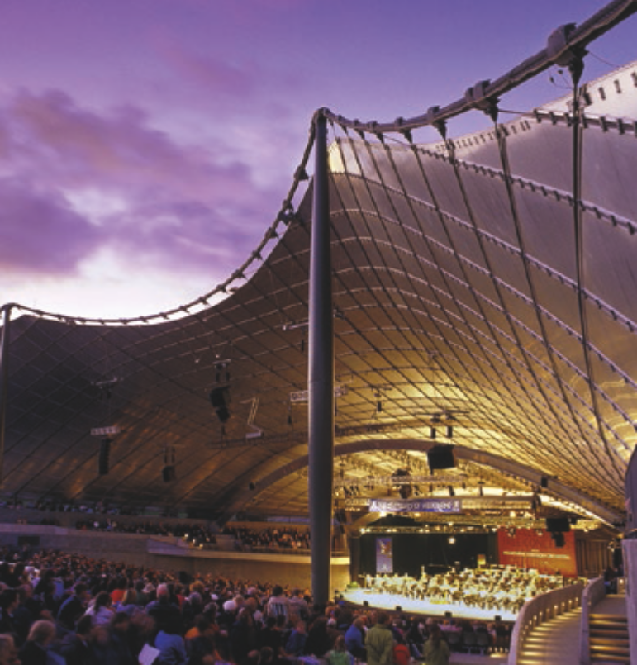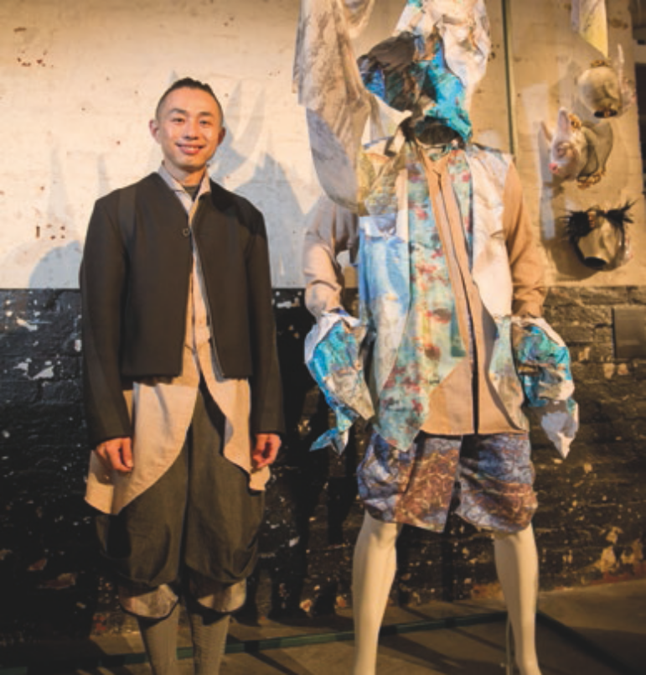

8 strategy.creative.vic.gov.au 9
5
Building international
engagement by positioning creative industries in the economic mainstream in addition to their already recognised cultural role.
- Creating a purposeful and long-term international engagement strategy, drawing together
existing and new activities
- Exploiting local capabilities and the phenomenal growth of the global digital games industry by strengthening global connections and business
- Supporting businesses to take advantage of one-off opportunities for international engagement
- Boosting cultural tourism, alongside enhancements to the State’s major events landscape
Benefits to the state
Creative and cultural
Economic and social

The significance of the cultural and creative industries

The creative and cultural industries have a positive effect on:

A RIPPLE EFFECT

From the individual who enjoys creative activities (captivation,

To the people they interact with (increased empathy, cognitive growth)

Culture and creativity have always been intrinsic parts of society, creating and reinforcing identity, and providing pleasure, new ideas, challenges, diversity and aspirations. Creativity has long been the basis for innovation and progress, disrupting settled practices and driving development. It has stimulated adaptation and reinvention in fields as diverse
as entertainment, agriculture, science, communications, medicine and, of course, the arts.
Victoria is an advanced society with a diverse economy and population, including a contemporary Aboriginal community grounded in a 60,000-year-old history. It is under constant pressure to find new avenues of growth and productivity, while managing resources sustainably. It must embrace and respond to external influences that can change the shape of the economy. Most economic value in the State now comes from the services industries (a contrast to historical strengths in manufacturing) and education is now Victoria’s strongest export. For its future growth, Victoria has reserves in the creativity of its workforce and industries on which it can and must call. Its sustainable strengths lie in the cultural and
  - Cultural and Creative industries in a global Context

Cultural and creative industries matter to societies and economies across the globe
The cultural and creative industries are globally regarded as increasingly important to the future. A 2013 report on the creative economy by the United Nations Educational, Scientific and Cultural Organisation summarised the relationship between culture, creativity and development in this way:
A much greater proportion of the world’s intellectual and creative resources are now being invested in the culture- based industries, whose largely intangible outputs are as ‘real’ and considerable as those of other industries. Human creativity and innovation, at both the individual and group level, are the key drivers of these industries, and have become the true wealth of nations in the 21st century.1
In 2007, in the preface to a resolution on a European Agenda for Culture, the Council of the European Union ‘stress[ed]

Individuals

Communities

The State
pleasure)

1. 2.
VALUE
GENERATION

3.

To the broader community (creation of social bonds, expression of communal meaning)

creative abilities of its people, businesses, communities and
organisations: collectively these provide the State with strong cultural foundations as well as the inspiration, innovation and agility to underpin future economic growth and liveability.
This chapter provides a snapshot of the importance and influence of the cultural and creative industries. It describes initiatives undertaken by a selection of other jurisdictions, highlighting the reasons driving others to develop strong cultural and creative industry strategies. Aspects of Victoria’s cultural and creative industries are also discussed, pointing to a number of distinctive strengths, as well as challenges,
to which actions proposed in this report respond.
that culture and creativity are important drivers for personal development, social cohesion, economic growth, creation of jobs, innovation and competitiveness’.2 The European Union has combined its media and cultural programs into a ‘Creative Europe’ strategy that aims to safeguard and promote cultural and linguistic diversity, and to strengthen the competitiveness of its cultural and creative sectors. From 2014 to 2020, it has committed €1.46 billion to strengthen Europe’s cultural and creative sectors.
The creative economy is one of the most rapidly growing sectors of the world economy, making up approximately 6.5–7% of global output in 2014. Core creative sectors contribute over 12% of Europe, America and Japan’s combined GDP, and a higher proportion of their growth. In the UK, the GVA of Creative Industries was worth £76.9bn to the economy, with 1 in 10 people working within creative industries, this is likely to rise to 1 in 8 people within the next five years (CAGR 2.3% over the last decade and a half).3
Governments, communities and industries are increasingly working in partnership to use creativity more effectively as part of their growth agendas: to better recognise and nurture these industries and the skills of their practitioners; to invest in them more widely and more often; and to capture a greater degree of benefit.
Economies and jobs are changing, and the
value of creativity is rising
In Australia, recent research suggests that up to 44% of jobs (or 5.1 million) are at risk from digital disruption over the next 20 years.4 There is evidence that cultural and creative jobs are more resilient and harder to outsource than any other jobs:
Creative jobs are proving more resilient to factors that are eroding the stability of other areas of the workforce. In particular, they are more resistant to outsourcing and to automation as they commonly involve creativity, interpretation, uncertainty, and complexity, factors that are difficult to engage with autonomously.5
In addition to operating in the mainstream, cultural and creative industries often operate at the ‘dynamic edge’ of societies
and economies: challenging and disrupting; innovating and educating; enlivening and enriching. Social and economic growth and prosperity are increasingly driven by the capacity of states and cities to renew themselves and diversify.

- UNESCO, ‘Creative Economy Report: widening local development pathways, 2013, p. 15.
- Official Journal of the European Union, C287/1, 29 November 2007.
- Peopleperhour (Meagan Crawford), The Rise of the Creative Economy, July 2015, p. 1.
- PwC, ‘A Smart Move: future-proofing Australia’s workforce by growing skills in science, technology, engineering and maths (STEM)’, (2015), p. 4.
- Nesta, ‘The Creative Economy and the Future of Employment’, p.3. See also PWC, ‘A Smart Move: future-proofing Australia’s workforce by growing skills in science, technology, engineering and maths’, (2015), p. 12.

the significance of the Cultural and Creative industries

Nesta
Nesta is a UK charity designed to promote innovation in science, technology and the arts, leveraging invention and creativity for greater public benefit.
The organisation backs promising ideas, harnessing money, knowledge and experience to develop those ideas to scale. In 2013–14, it supported 140 projects, with grants averaging £78,000.
Recent Nesta initiatives include:
- A research and development fund that supports creative ideas in galleries, museums, music and theatre
- A map of the creative economy to explore its weaknesses and opportunities
- The £7 million ‘Arts Impact Fund’, bringing together public, private and philanthropic investment in new social impact funding models
- Platforms, tools and promotion to help young people move from being users to makers of digital technologies
- Reports on the future of employment in the creative industries, the UK games industry, and new finance models for the arts.
One major initiative is Nesta’s ‘Digital R&D Fund for the Arts’, which supports arts projects that use digital technology to build new business models and enhance audience reach.
One of Nesta’s greatest success stories is National Theatre Live. Nesta’s investment allowed the National Theatre to launch a program of digital satellite broadcasts into cinemas in 2009. Now international in scope, National Theatre Live has made theatre accessible to lower income audiences in the UK and broadcasts in almost 400 cinemas worldwide.

Cultural and creative industries deliver economic and cultural benefits
Most cultural and creative strategies focus on either economic or cultural sectors but not both. Their scope varies widely and industries related to the production of art, film and television, design, publishing and software development are commonly, if not always, included. In some cases a broader suite of industries is included, such as journalism and media, tourism, education, and information technology. 6 The terms ‘cultural’ and ‘creative’ are imprecise. According to the Australian Bureau of Statistics:
'Cultural' is generally used to describe activities which communicate symbolic meaning (e.g. beliefs, values, traditions), require human creativity as an input, and potentially contain intellectual property, whereas 'creative' generally refers to activities for which human creativity is a particularly significant input. These terms are often used to describe activities connected with the arts, media, heritage, design, fashion and information technology.
An activity can be both 'cultural' and 'creative', and indeed, the terms are often used in overlapping ways in government, industry and academic circles.7
Regardless of precise definition, all jurisdictions with an emphasis on the cultural and creative regard creativity as a key input and economic driver and many include objectives around broader social and cultural benefits.

Our competitors are making significant commitments to the cultural and creative Industries
The United Kingdom has a 20-year history of developing and promoting cultural and creative industries, and is regarded by many as a leader in this space. In 2014, the UK government released a new creative industries strategy that aims to unite the different parts of the creative industries behind common goals and sets out a plan to ‘reinforce the UK’s place as world leader for the creative industries’. In the same year, Creative Scotland released a 10-year plan, which sets out its shared vision for the arts, screen and creative industries.
And in Canada, the cities of Toronto, Calgary and Montreal
all recognise and promote the importance of creative industries as key sources for growth and innovation and have specific policies and initiatives that support this.8
Closer to home, Singapore is establishing a reputation as a new Asia creative hub. It has built creative capacities, stimulated demand, developed targeted industries and integrated and emphasised design principles and practices across a range of enterprises: all of which position Singapore as a major media exchange, increase creative exports and foster a sympathetic regulatory environment and culture.
In Australia, all states, to varying degrees, have had – and continue to have – some focus on cultural and creative industries.

Decisive action by governments is having an impact
The increasing global interest in cultural and creative industries over the last 20 years has been driven by the idea that they deliver a disproportionate return on investment – returns that government action helps stimulate. Modelling in 2015 undertaken by the Arts Council England found that, even without taking into account commercial sectors such as
film, television and computing, the United Kingdom arts and culture industries’ ‘output multiplier’ is 2.15. That is, for every £1 increase in arts and culture output, there was a corresponding economy-wide impact of £2.15. 9

Walworth examined the cost effectiveness of music therapy as a procedural support in the paediatric healthcare setting. There was a 100% success rate in eliminating the need for sedation for paediatric patients receiving echocardiograms (ECGs), an 80.7% success rate for paediatric CT scan completion without sedation, and a 94.1% success rate for all other procedures. When the music therapy interventions were successful, no registered nurses needed to be present to assist. Cost analysis on the ECG patients alone for the 92 patients was $76.15 per patient, totalling $7,005.80. 10

The New Zealand program, Better by Design, has demonstrated the value of applying design to business operations with a structured approach to building design capability. The program evaluation in 2010 revealed that, across the 78 participating companies, overall revenue increased by 31% (with exports increasing by 52%). Companies experienced average annual growth more than five times the rate of GDP growth.

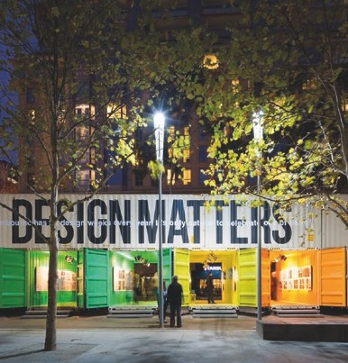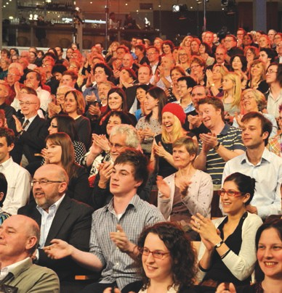Design Week (2015)

Melbourne Writers Festival (2009). Credit: Jim Lee

- See, for example, the classification system used by the World Intellectual Property Organization based on production of copyright works.
- ABS 5271.0, Cultural and Creative Activity, Satellite Accounts Report, 2009, p. 29.

9. Arts Council England, Centre for Economics and Business Research, ‘Contribution of the Arts and Culture Industry to the National Economy’, (2015), p. 27. Note: the ACE did not use the term ‘creative industries’.

the significanCe of the Cultural and Creative industries

  - The Victorian cultural and creative economy

Victoria has always played a pre-eminent role in Australia’s cultural and creative landscape
Victoria already has a thriving cultural and creative industries sector, encompassing disciplines as diverse as games development and graphic design, fashion and filmmaking, performing arts, literature and publishing, architecture, music, comedy, visual art and craft. Cultural and creative industries include activities that are commercially driven
and community-based, experimental and export-ready.
Victoria is home to the oldest orchestra in the country; the nation’s oldest and finest public library and gallery; the longest running professional theatre company and regional art galleries in Australia; and the national ballet.
Melbourne hosts one of the top three comedy festivals in the world; one of the most distinctive and irreverent circuses; strong independent theatre, literary and music scenes; various peak bodies and innumerable artist-run spaces and initiatives.
Victoria produces over half of Australia’s television drama,11 with recent international success stories including Miss Fisher’s Murder Mysteries, Wentworth, The Slap and Nowhere Boys demonstrating that cultural impact and economic benefits
are not mutually exclusive. The State is also home to half of Australia’s digital games industry, with more than 100 game development studios, animation houses and games industry service providers.12 In October 2015, Victorian developers claimed four of the top ten spots in the iTunes download chart in Australia and the United States.13
Melbourne is home to Australia’s only Centre for the Moving Image; Australia’s only Centre for Books, Writing and Ideas; Australia’s most popular museum; Australia’s premier arts training institutions; and is formally recognised as a UNESCO City of Literature, a prestigious designation that acknowledges the diversity and dynamism of local literary life.
Australia’s Aboriginal and Torres Strait Islander community is recognised as one of the oldest continuing living cultures in the world. Victorian Indigenous art is represented in respected Australian (and international) historical and contemporary art collections. The Koorie Heritage Trust houses a unique collection dedicated solely to the art and material culture of Victorian Indigenous communities.
Collectively, cultural and creative industries define the cultural landscape of the State and give it a brand, personality and profile that can be readily recognised, enjoyed and promoted. Victoria’s identity, like many places, owes its evolution and distinctiveness to the ideas and expressions of its cultural
and creative industries and the responses they stimulate.
Having vibrant cultural and creative industries is of central importance to contemporary Victoria. In a state such as Victoria, with comparatively high wages, standard of living and skills, cultural and creative industries will be the foundation for new avenues of economic growth. Success will belong to those who seek out and embrace the disruptive effects and transformative possibilities of applied creativity, emerging technologies, new forms of collaboration, and innovative responses to challenges and opportunities. In this competitive context, creativity, agility and continual renewal are critical.

Clunes Booktown Festival (2015). Credit: Aldona Kmiec
THE CREATIVE AND CULTURAL INDUSTRIES ARE DIVERSE
Museums
Environmental
heritage
Libraries
& archives
Literature &
print media
Performing arts
Design
Broadcasting, electronic
or digital media or film
Music composition
& publishing
Visual arts
& crafts
Fashion
Cultural goods,
manufacturing & sales
Supporting
activities

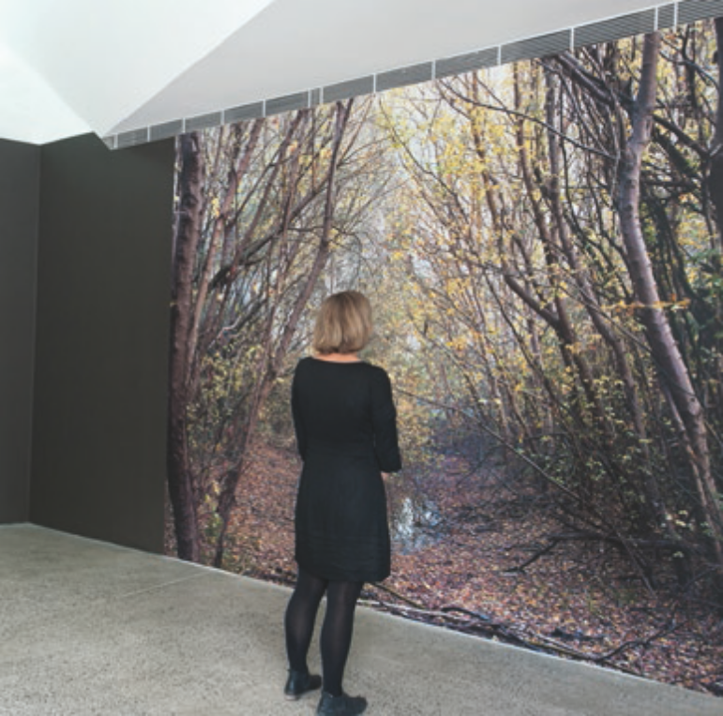Siri Hayes, Back to Nature Scene (2013)

- For 2014–15 financial year, Screen Australia, November 2015 (unpublished).
- Game Developers’ Association of Australia, ‘Skills and Capabilities in the Victorian Game Development Sector Review’, June 2015.
- Need For Speed: No Limits, developed by Firemonkeys; Shooty Skies by Mighty Games; Torque Burnout by League of Monkeys; True Skate by True Axis – all apps released in 2015.

the significance of the cultural and creative industries

The economic value of the creative economy to Victoria is more significant than many people realise
While cultural impact and benefits are prominent, the intention of a creative industries strategy should also be to increase and capture the economic and social benefits to Victoria.
The economic impact is already substantial, with revenue and employment growth much higher on average than that of other sectors.14 In 2013, Victoria’s cultural and creative industries directly contributed $22.7 billion to the Victorian economy in gross value add (GVA). This was just behind manufacturing at $26.3 billion and ahead of construction
at $19 billion. It represented 8% of Victoria’s total economy. The value of cultural and creative exports, based primarily on services, was $1.4 billion.15
In addition to their direct contribution, the cultural and creative industries support growth in other industries, by driving innovation through the application of creativity. In this way,
the creative economy has relevance and impact on the performance of the whole economy. The cultural and creative sectors and the people in creative occupations are vital to the sustainability and growth of other industries such as
manufacturing, biotechnology, food and finance, which employ and purchase creative services. The broad cultural and creative economy employs more than 220,000 Victorians, placing it at about 8% of total employment. In addition, 70,000 volunteers add a further $220 million each year to Victoria’s revenue.
Creative economy employment is made up of people working in the sectors themselves, whether or not they have creative roles, as well as all those who have creative occupations outside the cultural and creative industries. Around a quarter of creative economy jobs are in non-creative industries (e.g. an industrial designer at an automotive company); and about a third of employment is in supporting roles in cultural and creative businesses (e.g. an accountant in a theatre company).
There are substantial ‘spill over’ benefits from thriving cultural and creative industries through increased liveability and social capital. Cultural and creative activity boosts liveability, adding to a location’s attractiveness for tourism and immigration. For example, arts and culture are a major drawcard for Victoria’s visitor economy, with cultural tourism generating $1 billion for the State in 2013. These benefits are also recognised globally: in 2012, for example, a working group of European member states published a plan that outlined the potential of cultural
and creative industries to boost regional and local development.16

The social and community value of the sector is broad but not well understood
The cultural and creative industries also play a significant and often under-rated role in the delivery of social benefits.
For example there are cultural and creatively oriented programs that complement core government services and successfully address social and community issues in areas as diverse as education, justice, science, disability, community development and health. These impacts are less well understood and appreciated than economic impacts. The delivery of broader and more effective social outcomes through the application of cultural and creative input would be assisted by better measurement and coordination of investments across government.
In the area of education, a 2014 US study showed that primary school excursions to cultural institutions enhanced critical thinking skills, increased empathy and engendered tolerance. Students from disadvantaged backgrounds derived markedly higher benefits than other participating students, prompting the researchers to conclude that ‘the less prior exposure to culturally enriching experiences students have, the larger the benefit of receiving a school tour’. 17
A 2010 review of the role of the arts in the Australian education system found arts to be a critical component of education that provides students with the skills to meet the challenges of the 21st century. It reported that ‘it is now widely documented in the United States of America, Canada and Europe, including
in the United Kingdom, that those students whose learning is embedded in the Arts...achieve better grades and overall test scores, are less likely to leave school early, rarely report boredom and have a more positive self-concept than those students who are deprived of arts experiences’. 18

The pizzicato effect
Launched in 2009, The Pizzicato Effect is a partnership between the Melbourne Symphony Orchestra (MSO) and Meadows Primary School that improves the lives of students through specialist music training.
Inspired by the El Sistema model of music education, Meadows Primary students commence specialist music training at an early age, under the guidance of MSO teaching artists. In small groups, students learn violin, viola, cello or double bass, working, responding and playing together in a vibrant and collaborative environment. Older students participate in lunchtime ‘practice clubs’ and a bi-weekly after-school program, showcasing their talents at public performances.
Both teachers and parents at Meadows Primary School have reported overwhelmingly positive effects from the program, including dramatically improved focus, self- confidence and engagement in the students’ learning and behaviour.
Julie Cooke, Meadows Primary School principal, is quick to sing the praises of The Pizzicato Effect:
‘The program is affording our children so many valuable opportunities, and the transformation in the children and their confidence across all areas of learning and social interaction is without doubt. Yet the single most important achievement and benefit of the initiative, from my perspective, is that The Pizzicato Effect is helping our children take pride in who they are.’

The turnaround arts initiative
Established in the United States, this initiative delivers arts education programs and supplies to a group of the lowest-performing elementary and middle schools in the country. It has demonstrated dramatic improvement in academic performance – in maths, science and reading
– and also improved attendance rates and significant reductions in disciplinary problems, which is reflected in reduced suspension and expulsion numbers at more than half of the schools. The study’s key findings
include: students in the eight schools that incorporated arts programs into their regular curricula exhibited
an average 22.6% increase in math proficiency and a 12.6% improvement in reading proficiency. Those figures exceeded increases in their districts as a whole (20.1% and 7.9% respectively), and were markedly higher
than other schools in their states receiving federal school improvement grants (SIG) at 16.2% and 5.6% respectively. 19

CONTRIBUTING TO THE ECONOMY

Creative and cultural industries are significant contributors to the Victorian economy
VS
CREATIVE AND CULTURAL ECONOMY
$22.7B
29%
Gross value added to Victoria’s economy in 2013
Victoria has 29% of all Australian creative and cultural economy employees and an estimated 29% of national GVA
8%
Accounts for 8% of economy in GVA terms and is growing more quickly than the broader economy
$1.4B
$1B
$220M
Employing 222,000
people in 2013
Creative and cultural economy generates
$1.4B in exports
Cultural tourism 70,000
contributes $1B to volunteers
the Victorian contribute $220m
economy, anchored value to the
by international Victorian economy tourists
OTHER INDUSTRIES
Manufacturing Construction
$26.3B $19.8B
Agriculture, Forestry & Fishing
$8.1B
Mining
$6.5B

- Growth in the cultural and creative industries on average is more than double the rate of other sectors in the five years to 2013. Analysis conducted for Creative Victoria by Boston Consulting Group, 2015.
- Ibid.
- Jay Greene, ‘The Educational Value of Field Trips’, Education Next, vol. 14, no. 1, (2014), p. 79.
- Robyn Ewing, ‘The Arts and Australian Education: realising potential’, Australian Education Review, (2010), p13.
- http://turnaroundarts.pcah.gov/what-we-do/

the significance of the cultural and creative industries

Arts-based programs have also been shown to be effective in delivering public safety messages to youth,20 while art
therapy programs for offenders within the corrections system have been successful in reducing recidivism and facilitating social reintegration.21

Shakespeare Behind Bars
Founded in 1995 in Kentucky, USA, Shakespeare Behind Bars uses the works of William Shakespeare to engage prisoners with personal and social issues, helping them develop life skills that will aid their successful reintegration into society.
The program enlists prisoners to develop and stage performances of Shakespeare’s plays, including close reading of the text. It encourages learning and literacy, and helps prisoners develop decision making, problem solving and creative thinking skills, as well as empathy, compassion and trust.
Crucially, the program aims to help prisoners relate
the universal human themes contained in Shakespeare’s works to their own lives, including their past experiences and choices, their present situation and their future possibilities.
Shakespeare Behind Bars was the subject of a 2004 documentary film, described as ‘remarkable’ by the New York Times:
‘Inmates choose roles that reflect their feelings about themselves and their crimes. As rehearsals progress, and the men delve deeper into their characters, the line between role and self becomes blurred, and the play’s themes of forgiveness and redemption unlock long-buried emotions. The filmmakers, Hank Rogerson and Jilann Spitzmiller, encourage us to marvel at the transformative power of art.’
According to the most recent research, the average rate of recidivism for prisoners in the state of Kentucky is 29.5%; for graduates of the Shakespeare Behind Bars program, just 5.1%. 22

A more coherent understanding of the benefits arising from Victoria’s arts-based programs is the precursor to improving awareness and providing a stronger basis for assessment, improvement and development of new programs over time.
  - Opportunities for Victoria

Establishing a creative industries portfolio recognises their potential contribution
Victoria’s diverse and resilient economy and its highly skilled workforce have helped provide a strong foundation for robust future growth. In recent years, however, economic growth has moderated; GSP growth averaged just 1.9% per annum over the last six years. A flat GSP growth per capita indicates that economic growth has largely been driven by population growth. Labour productivity is slow, growing at less than half the national average over the five years to 2013–14. Business investment could, and should, be greater. While Victoria’s unemployment rate remains one of the lowest in Australia and is low compared to historical levels, it is trending up.
Many commentators argue that creativity will be vital to driving future growth.23 Cultural and creative industries in Victoria are well placed to provide the necessary capability.
The establishment of a creative industries portfolio is a new and welcome development. Creative Victoria is the amalgamation of the previous Arts Victoria with several other creative industry functions, principally from the design and screen sectors,
to maximise their collective cultural, social and economic potential. The placement of Creative Victoria in the new Department of Economic Development, Jobs, Transport and Resources was deliberate and signals the intention to look for new and better ways to capture and deliver value from the cultural and creative industries. In Creative Victoria, the cultural and creative sectors have a significant government body dedicated to supporting and championing their growth; in arguing for their greater recognition; and in advocating for
their role in delivering value across all facets of life in Victoria.
Considering the more and less commercial parts of the sector together recognises that the line between them is impossible (and probably not useful) to define. It provides for more consistency in the treatment of individuals, businesses,
institutions and organisations in the sector, and the interactions between themselves and the broader community. It will achieve a greater critical mass of expertise, value, investment and profile. It will strengthen collaboration within cultural and creative industries as well as across other public and private enterprises. An integrated portfolio also responds to common educational foundations and the fact that they rely on key creative skills of problem solving, expression and analysis.
A unified vision for Victoria’s cultural and creative industries will help Victoria maximise the benefits of State investment in the cultural and creative industries, and protect and enhance Victoria’s competitive advantages.
The ability to produce great art and creative content for cultural, economic and social benefit is supported by the same ecosystem involving skills and training, personal and professional development, financial and promotional support, collaboration and experience. Creative practitioners who operate mainly in the art space can help, as well as learn from, those primarily engaged in commerce.
In this context, there is great value in government support that is not geared exclusively towards one sector or another but, rather, encourages and facilitates their stronger integration, and that has a focus on improving the overall ecology and outcomes. Bringing these sectors together under an integrated policy framework has the greatest potential to encourage innovation and efficiency, and to enable new opportunities.

Victoria can draw on distinctive strengths and assets
Victoria has a highly skilled workforce, substantial digital infrastructure and a demonstrated willingness across almost all sectors of the community to adapt early to new and emerging technologies. It has a strong and diverse environment of education services, capabilities and infrastructure – strong enough to support a growing population and to attract statewide and international placements and contributions. The State is home to a dynamic and distinctive Indigenous culture and a diverse, vibrant and cohesive multicultural population.
Victorians place a high premium on relationships, not just transactions. Victoria has a strong culture of social and philanthropic activity that draws on diverse sections of the community – business, independent arts sector, sport, philanthropy in well-established and constantly evolving formal and informal networks.

Australian Print Workshop
The generous support of The Collie Print Trust enabled the Australian Print Workshop (APW) to forge a major partnership with the Cambridge Museums network. Under the guidance of the APW, three Australian artists were reinterpreting some of Britain’s most significant museum collections in the Antipodes project.
Early in 2015, the APW brought the Australian artists to Cambridge for an immersive journey through
the Museums’ collections, exploring a wealth of archaeological and anthropological material including artefacts from Captain Cook’s voyages to Australia.
In the 12 months following their trip, the artists – Brook Andrew, Tom Nicholson and Caroline Rothwell – were working with the APW to produce a series of works based on their experiences, for exhibition by the University of Cambridge Museum of Archaeology and Anthropology in 2016.
APW Director Anne Virgo said that building international ties for Australian artists is an essential part of their advocacy work: ‘[Antipodes] was about providing
a fantastic opportunity for Australian artists to go abroad. These artists have global presence: they exhibit internationally and have connections and contacts around the world, which is a crucial element of their professional practice.’

Victoria enjoys world-class cultural infrastructure and experiences. It is the nation’s smallest mainland state, and provides relatively well-integrated and accessible
transport networks and services, allowing for the manageable movement of people and products and the servicing of regions more easily than any other state or territory.
Victoria has an extensive network of high quality regional galleries, libraries and performance arts centres, which are a social and cultural focus of communities, and which
draw tourists and economic value to the regions. For example, the Grace Kelly: Style Icon exhibition at Bendigo Gallery in 2013 brought $16.3 million into the local Bendigo economy over 100 days. These cultural facilities are complemented
by thriving local music scenes, active touring circuits and successful creative businesses.

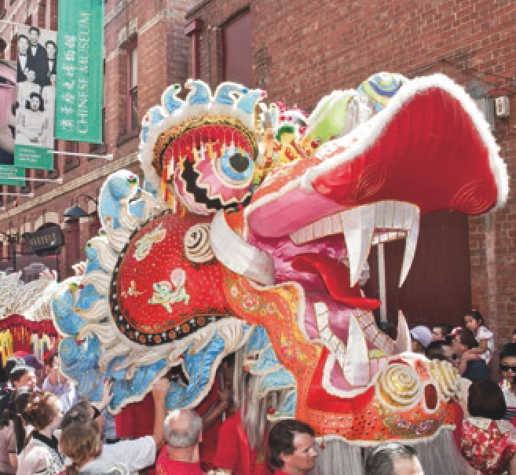20. Lake-Hui, Q., White, A., Low, C., Brown, J., Dalton, N., Connor, J. (2012), “Good choices, great future: an applied theatre prevention program to reduce alcohol-related risky behaviour during Schoolies”, Drug and Alcohol Review, Vol. 31, pp. 897-902.21. http://www.shakespearebehindbars.org/
22. Ibid.
Chinese New Year 2013

The significance of the cultural and creative industries

Victoria’s screen industry is a vibrant and important component of the cultural and creative industries, contributing around $1.4 billion per annum into the economy and employing over 11,000 full-time equivalent employees24. In addition to being the home of world-renowned Australian drama such as Wentworth and Miss Fisher’s Murder Mysteries, 2015 has also been a successful year for Victorian made feature films at the box office with The Dressmaker and Oddball.

Wentworth
Wentworth is a modern re-imagining of the iconic Australian television drama series, Prisoner whose home was Melbourne. Wentworth maintains this Melbourne link and FremantleMedia has a continuing commitment to producing high quality internationally recognised drama in Victoria.
In 2013, Wentworth premiered on Foxtel’s SoHo channel, with the first episode of Wentworth Series One becoming the most watched non-sports program ever on Australian subscription television.
Across the 10 episodes of Series One, Wentworth reached 1.868 million unique viewers, representing 25% of Foxtel subscribers. The popularity of the show continued into a third season, which went to air in April 2015. A fourth season commenced filming in August 2015 for release in 2016.
The show spent almost $35 million in the State and employed an average of 565 people per series.
Wentworth became an international success, first in New Zealand and then in the United Kingdom, attracting more than two million viewers each week. Wentworth was sold into 89 territories, including the United Kingdom (Channel 5), Ireland (TV3) and Africa (MNet).
A Dutch adaptation of the Foxtel show, locally titled Cell Block H, was one of the highest rated shows in the Netherlands. A German adaptation was in production late in 2015.
Melbourne is consistently recognised for its liveability, a ranking that relies, in part, on the quality of its cultural assets and experiences. Its status as the world’s most liveable city gives
it, among other things, an international profile that assists in attracting and retaining talent. Melbourne’s standing as a UNESCO City of Literature is one of the State’s strengths that
can be used to inspire and better engage communities: to build greater interest and appreciation in literature and culture; and to share new and novel approaches to reader development, literacy and learning.
Trade, investment and demand for Victorian creative services and cultural products are well served by the State’s proximity to Asia and its growing demand for creative products and services.
Victoria is well placed to take advantage of these opportunities.

The Dressmaker (2015). Credit: Courtesy of Film Victoria
  - Challenges for Victoria

Victoria faces challenges in nurturing its cultural and creative industries and capturing the benefits
Despite Victoria’s premier position in the national landscape, continual changes in the operational environment demand ongoing work to maintain areas of leadership, to improve
or reinvigorate performance where needed, to respond to competitive challenges and to take advantage of new opportunities.
There are specific areas where action needs to be targeted and where government intervention is likely to make a positive impact. Rates of participation in the cultural and creative industries at school, at work and in the community are inadequate; pathways into creative careers and sustainable practice are unclear and difficult to navigate; while technology development and international competition are putting more pressure on creative practice. The understanding of the range of benefits that can be derived from the cultural and creative industries, particularly in social areas, is too limited.

Opportunities to participate and benefit from Victoria’s cultural and creative industries are not equitable
Victoria cannot claim that its population has adequate or equitable engagement with arts and cultural experiences. Its regions and outer metropolitan areas are not as well serviced as Melbourne. Victoria’s rich and important Indigenous heritage and its multicultural communities are defining strengths of the State, yet the products, employment and audiences do not accurately or adequately reflect this diverse cultural make-up. Similarly, workers, practitioners, performers and audiences with a disability face unacceptably high barriers to access and are under-valued and under-represented in the cultural and creative industries. A new strategy provides an opportunity
for effective targeting of under-represented groups to help smooth out disparities and raise overall rates of participation.
Demand for art in public and community spaces is also not being met. As urban development intensifies over the coming years, there will be an increasing need to demonstrate leadership in promoting the role of architecture and urban planning to ensure high planning and design standards, adequate provision of creative and community spaces,
and access to public art in Victoria’s cities and regions.
Victoria has a strong local government network. Local governments are critical in providing access to creative experiences and services for communities throughout Victoria. The State Government, through Creative Victoria, has established relationships with many of these local councils, which range from co-funding cultural infrastructure and creative organisations
to formal Memoranda of Understanding. Some of these relationships are strong and some could be further developed. There would be great benefit in streamlining and strengthening the way different tiers of government engage with and support cultural and creative activity. In addition to being more efficient, this would benefit both the sector and the community.

The potential of culture and creativity is not adequately understood early in life, and pathways into sustainable creative work are weak
It was clear from consultations that the current engagement of young people with art and creative practices is inadequate. A higher value must be placed on the development of creative people, whose level of interest and individual outputs will be the foundation for success. Victoria currently has significant
room for improvement in terms of the pathways between school education, tertiary study and creative careers. At present
these pathways are poorly defined and difficult to follow, and employment outcomes for arts graduates are relatively poor.

“At the moment, there is an inequity in the opportunities people have to participate in and benefit from the
arts. The key to this inequity is that the importance of creativity is underestimated and misunderstood and that this happens very early in life. When I was growing up, I never considered that following my creative drive was a viable way to earn a living. Such instincts were encouraged perhaps as an avocation but never as a vocation. In my mind’s eye, I knew what I dearly wanted to end up doing but could see no way of getting there. There were no roads, no sign-posts, no guides; nothing to indicate that the creative pathway was a legitimate route to anywhere. A life in the arts cannot be one of indulgence. One way or another, the market is where we all end up. But it is seldom a direct trip. Often times, it’s the getting there that’s the point.”
Shaun Micallef: actor, comedian and writer.

The significance of the cultural and creative industries

There is also too little support for professional creative practice throughout all career stages. For individual practitioners,
the development of creative and artistic practice can be slow and fraught. Financial sustainability of creative practice was a key issue arising during consultations, with many
organisations claiming difficulty in generating enough revenue to cover costs. Most cannot live on their creative work alone: the personal investment is invariably high and the rewards uncertain. Increasing competition for leisure time and audience attendance, and uneven levels of cultural engagement across the State make income from creative content unreliable and inadequate to sustain ongoing development.
Victorian cultural and creative businesses generally lack scale and many don’t have enough time, funding or the right skills to create an effective business model to sustain or expand their work. There are too few opportunities for creative
practitioners to gain training aligned to work rather than study. Certain content industries such as book publishing, film and music are being transformed by technology, and they are simultaneously having to fight piracy, combat competition from entirely new players and devise new business models as the structures underpinning the old ones fall away. Collaboration and co-working can help to address some these deficiencies but rates of collaboration in Australia are low.25 Victoria already has a number of co-working spaces but consultation strongly
suggested that demand is currently not being met. More needs to be done to generate effective and affordable shared space, and not just in metropolitan locations.
Victoria has a wonderful array of festivals operating across the State, which should provide new and challenging cultural experiences. They should also help practitioners build wider audiences. Respondents questioned whether the Victorian festival landscape as a whole currently offers enough that is
varied, ambitious or outside the mainstream. They questioned whether Victoria’s festivals provide sufficient opportunities
for local practitioners to showcase their work. The common theme was that much more could be done.

International links could be better developed
Victoria is a relatively isolated and small market compared to that of Europe or North America, so it has to do more to make an impact on the global stage in areas like cultural tourism. The local market for creative services, such as design, is small by global standards and, while local demand
is increasing, ambitious firms face the challenges of exporting to achieve growth.
The State has established relationships with markets in the United Kingdom, Europe and the United States but the closer markets in Asia have enormous and relatively untapped potential. The benefits of exposure in these markets will more than compensate for any difficulties involved in building the necessary relationships and trade.

Government can help build local capability and support ambitions to reach larger, more challenging markets overseas not only by effective policy but also through procurement.
As a substantial buyer of creative services, Government could have much greater impact on development of local
providers by employing more flexible and creativity-conscious approaches to procurement.
The actions proposed in this report are designed to build on Victoria’s distinctive collection of strengths as well as addressing current challenges.

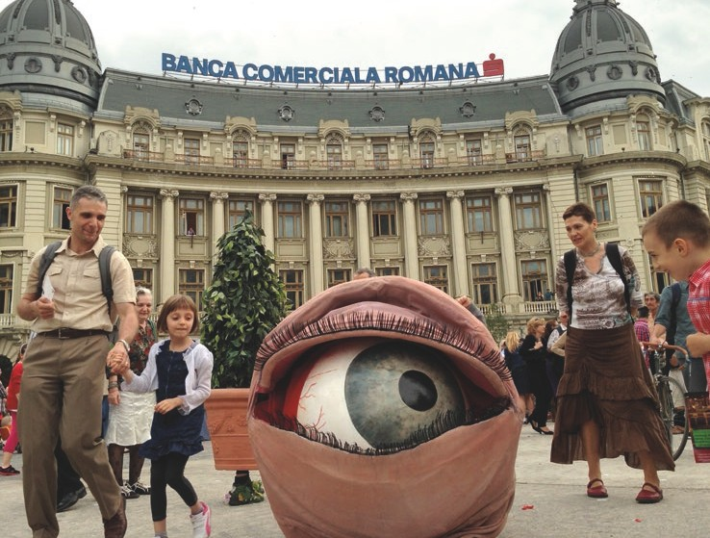Big West Festival (2013) Snuff Puppets Human Body Parts at B-Fit in the Streets Romania image by Bogdan Christel

25. Organisation for Economic Co-operation and Development, ‘Firms Engaging in Collaboration on Innovation by R&D Status 2008–13’ in Science, Technology and Industry Scoreboard, 2013.

The response:
Creative State Global City

  - Overview
Victoria has committed to a creative industries strategy, and in doing so it should not reproduce other models.
The most effective strategy will take into account Victoria’s unique assets, capabilities, culture and history. It should address the gaps and challenges that Victoria faces and
it should deliver the benefits that Victoria most needs.
The vision is to build our cultural and creative industries
to transform Melbourne into a global as well as liveable city, and establish Victoria a truly creative state. This vision
will require seizing specific opportunities, drawing on established strengths and addressing specific challenges. Achieving such a vision will depend on the extent to which:
- A vibrant and rich, cultural and creative sector with prolific, innovative practitioners
- There is a thriving creative ecology and businesses
- Creativity is applied to add value across industry, education and public services
- Arts and creativity are valued by the local community
- Strong international engagement is ubiquitous.

These outcomes are the hallmarks of global cities and creative states. The Taskforce proposes five areas of focus to achieve these outcomes. These focus areas work together by targeting particular areas but contribute to achieving all the outcomes in different ways and to varying degrees. They are:
1
Backing creative talent by creating more
opportunities to produce and present great work.
Hallmarks of a global City, Creative state
2 | Strengthening the creative industries ecology by building capacity and unlocking opportunities to reach audiences and markets.
3 | Delivering wider economic and social benefits through the application of creativity and using Creative Victoria as a force for collaboration.
4 | Increasing participation in and access by setting high standards for education, access and public events and broadly promoting the value of art and creativity.

What’s required to make Victoria a Creative State and Melbourne a Global City?

aspiration

The cultural and creative industries make Victoria a creative State and Melbourne a global as well as liveable city
Building international engagement by positioning
5 creative industries in the economic mainstream in addition to their already recognised cultural role.

This chapter elaborates on each of these focus areas and why they were developed, while Chapter Three describes the specific initiatives aligned to each one. The overall framework, illustrating the relationship between the vision, outcomes and focus areas, follows.

A vibrant and rich, cultural and creative sector with prolific, innovative practitioners

Creativity is applied to add value across industry, education and public services

Thriving creative businesses

Arts and creativity are valued by the local community

An internationally engaged cultural and creative sector
areas of focus and actions to make Victoria a Creative state and Melbourne a global City
1 | Backing creative talent by creating more opportunities to produce and present great work.
2 | Strengthening the creative industries ecology by building capacity and unlocking opportunities to reach audiences and markets.
3 | Delivering wider economic and social benefits through the application of creativity and using Creative Victoria as a force for collaboration.
4 | Increasing participation and access by setting high standards for education, access and public events and broadly promoting the value of art and creativity.

5
Building international engagement by positioning creative industries in the economic mainstream
in addition to their already recognised cultural role.

Benefits to the state
Creative and cultural
Economic and social

The response: creative state, global city

“Last year I was asked to give a talk at the Melbourne Uni Law School. They were about to put on a show. A few months after giving the talk, I was invited to the show.
A few months after the show, I invited a couple of the funnier members of the cast to watch my TV show, Mad as Hell being made. I told them it was important to see how boring it was to make. They took part in small roles on location and in the studio. I would have loved to have done that when I was young. You can’t learn a talent; you either have it or you don’t. What you can learn is the technique and grammar of your collaborators so you can adapt your talent to different forms of media. Over the years I’ve learned how to adapt whatever I can do on stage to TV. I can re-tool what I think is funny to suit the small screen. What I could do in front of a group of friends when I was 15, I can now do with a group of
a hundred collaborators. I can produce TV comedy because when I started as a writer 20 years ago on a show called Full Frontal, I watched the editors and the set builders and the director and the script editor and the sound guys and learned their language. I learned to break down all the things I did naturally and instinctively when communicating to an audience and see that the responsibility for these was hived off to the different departments. These were valuable lessons and I think anyone who wants to make it in TV comedy would benefit from access to the technicians. Just watching them work would do it. In my view, any scheme where young comics could be granted access to a working TV production would be a worthwhile venture.”
Shaun Micallef: actor, comedian and writer.

  - Benefits of making Victoria a creative state and Melbourne a global city
Hallmarks | Tangible benefits that will result
A vibrant and rich, cultural and creative sector with prolific, innovative practitioners | Victorian creative workers have outstanding opportunities to develop their practices and skills; and devote time to producing significant work.
Thriving creative industries | Cultural and creative businesses and organisations across the State have access to the skills, infrastructure, audience development and support to grow. There are good, accessible and affordable options for sharing space, facilities and resources to undertake collaborative projects.
Creativity is applied to add value across industry, education and public services | Collaboration occurs between creative sectors and industry, education and public services, whether for commercial, creative, social or other purposes. There is stronger awareness of how well creative services can influence outcomes in other sectors and growing demand.
Arts and creativity valued by the local community | People of all ages, abilities, cultural and socio-economic backgrounds have affordable opportunities to engage with, study and pursue careers in the cultural and creative sectors. Victoria’s regions are well served with cultural experiences. Public events stimulate and inspire.
Strong international engagement | Victoria has an engaging, year-long calendar of high-quality, major cultural events that attract tourists from across the globe. Victoria’s cultural and creative  practitioners, businesses and other organisations operate in a global context, have productive relationships with overseas counterparts and export their product.

  - focus areas

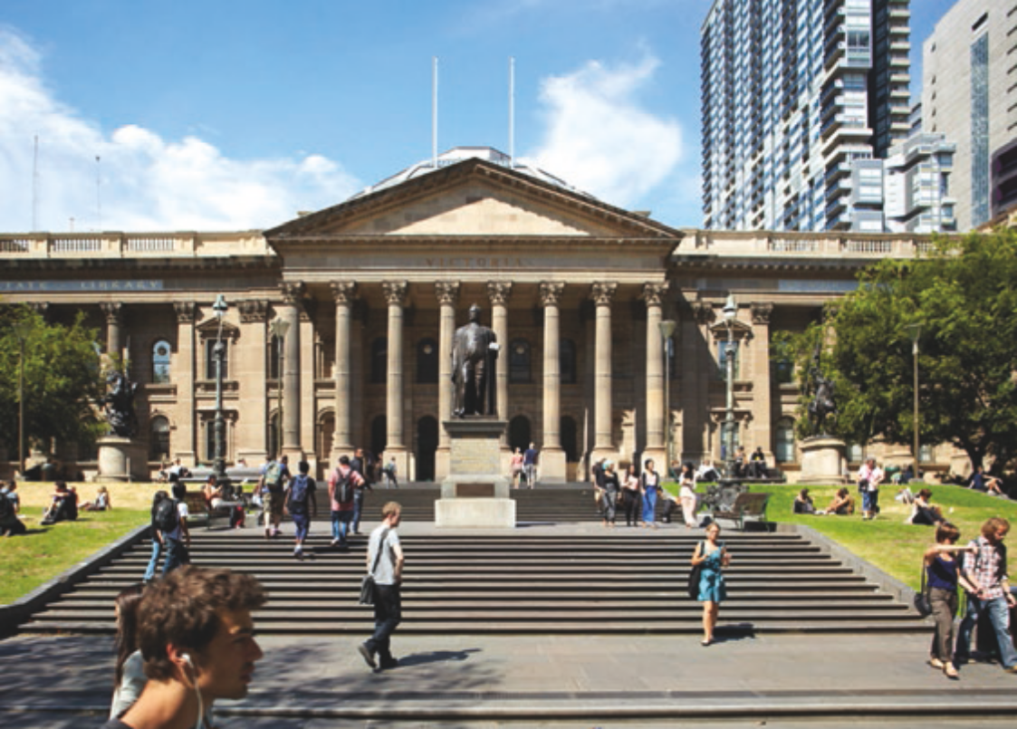
State Library of Victoria: Photo credit: Andrew Lloyd

FOCUS AREA 1
Backing creative talent by creating more opportunities to produce and present cutting edge work

Global cities and creative states have depth and breadth in cultural and creative endeavour. They are home to cultural and creative practitioners at all stages of their careers – emerging, mid-career and established. They have a strong pipeline of talent sourced locally and globally. The work they produce is diverse and appeals to a wide range of ages, backgrounds, dispositions and aspirations. The work is at different times provocative and deeply recognisable, multi- and mono-disciplinary. Above all, it is never ordinary.
At the heart of the cultural and creative industries is the quality and ambition of creative thinking and output from individual artists and other creative practitioners. Creative work spans
a broad spectrum from traditional art forms to experimental or multi-disciplinary content, techniques and styles. It should challenge audiences and continually add to the cultural richness of the State. It matters that the work of the Australian cultural and creative industries tells Australian stories that underpin and renew Australian identity, culture and society, just as it matters that creative industry ambitions are not constrained by culture, location or background.
The development of creativity and artistic practice can, however, be slow and fraught. Many creative practitioners cannot live on their creative work alone. The personal investment is invariably high and the rewards uncertain. Collaboration and a tolerance for experimentation and strategic risk-taking – often vital components of creative development – are challenging. And even when the talent and the necessary supporting infrastructure and training are available, success is not assured.

‘Victoria should be an ideas-driven cultural economy and be known for the boldness of its vision, the fearlessness of its programming and its willingness to take risks.’
Melbourne International Film Festival
The growth and nurturing of excellence in the cultural and creative professions is, therefore, foundational for the success of the cultural and creative industries. If there is a lack of depth, diversity and ambition in cultural and creative industries then ‘the emperor has no clothes’.

‘Reward risk-taking. Change the definition as to what constitutes success or failure in an artistic product.’
Victorian Opera
The Taskforce considers that government action can create more and better opportunities for creative practitioners to produce and present great work. Chapter Three proposes initiatives for:
- Supporting the most talented creators and new, landmark works of scale
- Providing access to professional development programs
- Providing incentives for creators to collaborate.

The response: creative state, global city

Venues and other physical infrastructure are necessary and require substantial funding to build and maintain.

FOCUS AREA 2
Strengthening the creative industries ecology by building capacity and unlocking opportunities to reach audiences

Matchbox pictures
Matchbox Pictures has become one of the most dynamic production houses in Australia, developing and producing scripted and non-scripted television programs and feature films for audiences throughout the world.
The Government, through Film Victoria, first provided support, in the form of slate funding to the production company and its individual producers, in 2002. This early investment, along with further support at state and federal level since then, demonstrates a long-term approach to industry development that has resulted in significant growth and economic benefits for Victoria.
Starting as Big and Little Films, Matchbox Pictures was formed in 2008, with assistance from Screen Australia’s Enterprise Australia program. During 2008
to 2011 Matchbox Pictures delivered an impressive and diverse slate of drama and documentary which saw it recognised as the 2011 SPAA Producer of the Year.
In 2011 there was further recognition as NBCUniversal (NBCU) UK took a majority stake in Matchbox Pictures, and then acquired the company in 2014. This investment recognised the strength and capability of the local screen business and has provided Victorian projects with greater access to a global distribution market.
Matchbox Pictures realises up to 12 concurrent projects a year – producing a range of content for the global market including television drama, children’s programming, factual and entertainment content, animation and feature films for the domestic and international marketplace, alongside games and apps to enhance its programs.
The company now employs 29 core staff in Victoria, New South Wales and Queensland and many more production personnel in each state, with turnover multiplying several times since the formation of the company. An international office, Matchbox Asia, was formed in 2013 to foster strong connections with the Asian screen market. The growth of Matchbox Pictures now sees them rival long-established players such as Southern Star and FremantleMedia.
In 2014, Film Victoria secured two NBCU television series to film in Melbourne. Having Matchbox Pictures as a subsidiary of NBCU was beneficial for delivery of production services on this project.

The flying dutchman 3 d
In 2014, with support from the Australian Research Council, the Deakin Motion.Lab and Victorian Opera embarked on a three-year project to explore
how 3D could be used to bring opera to life. The first of three proposed collaborations was Wagner’s The Flying Dutchman: notoriously difficult to stage and ripe for reimagining.
‘We wanted to see if we could use the 3D technology in a well-known, mainstream work,’ says Professor Kim Vincs of Motion.Lab. ‘There have been a number of experimental operas where the technology is a driving force in the composition; where the works are written for the technology. But here, we were taking a long-established repertoire opera and seeing what we could do, aesthetically, if we brought the richness of
a cinematic language to the scenography; if we could make a more contemporary statement with what is a very traditional work.’
Presented at the Palais Theatre in February 2015, The Flying Dutchman 3D was the product of six-months’ work at Motion.Lab, creating fully immersive 3D scenery that provided an illusion of depth unimaginable for an opera set just a few years ago.
Richard Mills, Artistic Director of Victorian Opera, notes the outstanding critical reception the production
– the first of its kind anywhere in the world – received: ‘When the two worlds came together, welded by the power of the orchestra, something magical happened, because we allowed the voice and scenic intentions of the composer to be realised in a way we could never have thought possible.’
The focus of activity, however, should be less about new physical infrastructure and more about the people, spaces and connections that create and consume cultural and creative work.

Individual practitioners are essential to a vibrant creative State. However, Victoria needs a strategy that nurtures all parts of the ecosystem, enabling individual practitioners to thrive alongside cultural organisations, businesses, entrepreneurs and infrastructure. A strong ecosystem will support a dynamic interplay between disciplines and across enterprises. It has a continual pipeline of activity and work that creative businesses can rely on to employ staff and invest in business infrastructure and future growth.
Cultural and creative organisations of all sizes, both commercial and not-for profit, are part of an ecology responsible for the development, production, presentation, exhibition, sale and export of creative content, from
music to visual arts to film, television and theatre. There is much to be gained by accelerating the development of
more entrepreneurial cultural and creative businesses and organisations, by activating spaces and opportunities to work and exhibit creative content, by providing the means to constantly retune skills to evolving needs.

‘A healthy cultural ecology needs investment in all aspects of the “value-chain” – in new product and programs, in hard and soft infrastructure as well as in development of new audiences, both in person and online.’
Asialink

Parts of the sector, including theatre, digital games, television production, architecture and design businesses are already highly commercial with potential for greater growth. Less commercially focused organisations are part of the same ecology and, whatever the type of organisation involved,
they all contribute innovation capability and can draw on the ecology to support their own different needs and priorities. Initiatives should ensure that sub-sectors with identifiable strengths and obvious market potential are supported.

Government should aim to ensure that the conditions for the production of work, and accessibility to audiences and markets are as favourable as possible, that barriers are

‘A truly innovative strategy will understand and support each element, from the major agencies to the “long tail” of small-to-medium organisations and their peak bodies, plus individuals in embedded, specialist and support occupations.’
Museums Australia (Victoria)
minimised or removed and that collaboration can easily occur.
The Taskforce proposes specific initiatives in Chapter Three designed to improve the cultural and creative ecology, which cover four key areas:
  - Improving the sustainability of cultural and creative organisations
  - Accelerating the development of entrepreneurial cultural and creative businesses and organisations
  - Expanding availability of spaces for artists and creative practitioners
  - Strengthening the management and technical skills base.

The response: creative state, global city

FOCUS AREA 3
Delivering wider economic and social benefits through the application of creativity and using Creative Victoria as a force for collaboration

Creativity is not confined to the cultural and creative sectors. It underpins the achievement of a wide range of economic benefits across all industries as well as contributing to social outcomes in areas such as justice, education and health.
The importance of creativity is illustrated by patterns of employment. Victoria’s creative economy includes those employed in the cultural and creative sectors, like visual arts, design, dance, theatre, exhibition, music and film production. It also includes those who work in creative roles elsewhere, like industrial designers employed in manufacturing, art teachers in schools, digital media artists for publishers, visualisation specialists in ‘big data’ enterprises. In fact,
more than a third of employment in creative occupations occurs outside the cultural and creative sectors. 26
Creativity applied more broadly provides a sound foundation for economic and social innovation, leading to new value and opportunities in constantly evolving ways. One of the best examples is the application of design. There are more people employed in design-related roles outside the Victorian design sector than there are within it. Victoria has a strong design culture and capabilities but needs to make up significant ground on international benchmarks for design adoption and application within enterprises. There is ample research to show that businesses using design are more profitable, outperform their competitors and grow at faster rates.27 There are similarly strong correlations between other forms of creativity and economic benefit.28
Where creativity, in the form of cultural and artistic experiences and skills, has been applied to social needs, it has resulted in markedly lower rates of recidivism, improved rehabilitation and disease prevention, more positive schooling and better grades.29
The Taskforce sees the establishment of Creative Victoria as an opportunity to bring forward and extend the benefits
of creativity across Victorian industries, public organisations and not-for-profit services more quickly and more broadly
than would otherwise occur. A fundamental role of Creative Victoria should be to drive systemic collaboration between cultural and creative industries and other parts of the public service and industry – systemic, because it must become a part of the functioning of a society and a state. Government can also encourage artists, though funding programs, to
co-design their work with the people and communities for whom it is intended in order to make it more relevant and meaningful to them.
Government can help stimulate more social and economic value by educating people and organisations about the value of creativity, and encouraging the use of creative services to transform behaviour. While there is anecdotal evidence of the many ways in which cultural and creative activity improves the
lives of individuals and communities, it is complex to capture the kind of robust evidence of causal impact that leads to substantial investment. The challenge is to build evidence regarding the benefits of the arts and collaboration to diverse stakeholders,
to optimise those benefits and to create the conditions in which collaborative approaches are valued, enabled and constructive.
Chapter Three describes specific initiatives proposed by the Taskforce to boost creativity-inspired collaboration across the State in four key areas:
- Capturing larger social dividends from Government funded arts and cultural initiatives
- Leveraging better information to regularly quantify and publicise the benefits of Victoria’s cultural and creative industries, including a benefits analysis of services used by local and State government
- Stimulating greater application of cultural and creative services across government
- Enhancing application of design to improve liveability and capture stronger triple bottom line benefits.

School children watch The Barber of Seville, Opera Australia Education (2013). Credit: Ben Symons
‘In the digital age creativity is collaborative.
A progressive strategy fosters networked communities that co-design and create our future.’
Online Consultation ‘Post-it note’ (yarra64)

Rawcus, Singular (2013). Credit: Pia Johnson

FOCUS AREA 4
Increasing participation and access by setting high standards for education, access and public events and broadly promoting the value of art and creativity

Art, culture and creativity are intertwined with human development itself. Creative engagement plays a critical role in regenerating cities and regions. Attracting a younger demographic, underpinning tourism and meaningful engagement with cultural experiences from an early age are all vital for the growth and strength of communities.
A variety of indicators of ‘revitalisation’ – reductions in poverty, lower levels of social stress, fewer incidents of ethnic and racial harassment – are correlated with measures of cultural engagement.
The quality of cultural and creative education matters for three reasons. First, it builds the supply of talented creative practitioners, some of whom will go on to make important cultural and creative contributions to their communities.
The more practitioners we can foster, the richer the community. They may become artists themselves or they may apply creativity in other ways. Second, providing creative exposure and skills from a young age builds participation and audiences of the future. Third, cultural and creative engagement is sound pedagogy and engages learners – whether engaging the disengaged through digital games technologies or teaching about leadership through the structure of an orchestra.
‘Active participation, collaboration and representation by all sectors of the community in its cultural life is
an important ingredient in developing and promoting wellbeing, a sense of place and belonging for all citizens.’
Multicultural Arts Victoria

- Supra note 14.

Philosophers and autonomous vehicles
Should a self-driving car swerve to avoid hitting a kangaroo if swerving places pedestrians in danger? Answer: Engage a philosopher.
Chris Gerdes, a professor at Stanford University, leads a research lab that is experimenting with sophisticated hardware and software for automated driving. Together
with Patrick Lin, a professor of philosophy at Cal Poly, he is also exploring the ethical dilemmas that may arise when vehicle self-driving is deployed in the real world.
Gerdes and Lin organised a workshop at Stanford earlier this year that brought together philosophers and engineers to discuss the issue. They implemented different ethical settings in the software that controls automated vehicles and then tested the code in simulations and even in real vehicles. Such settings might, for example, tell a car to prioritise avoiding humans over avoiding parked vehicles, or not to swerve for squirrels.
Engaging engineers and philosophers to work together in this way, applies disparate creativity to new and emerging challenges – and is indicative of the type of creative problem-solving that is necessary to resolve emerging and future challenges.
Select extracts from MIT Technology Review, 29 July 2015
- Victorian Government, ‘Five Years On: Victoria’s design sector 2003–2008’; National Agency for Enterprise and Housing, Denmark, ‘The Economic Effects of Design’, (2003).
- Martin Prosperity Institute (Richard Florida et al), ‘Creativity and Prosperity: the global creativity index’, (2011)
- Supra note 14; Lake-Hui, Q., White, A., Low, C., Brown, J., Dalton, N., Connor, J. (2012), “Good choices, great future: an applied theatre prevention program to reduce alcohol-related risky behaviour during Schoolies”, Drug and Alcohol Review, Vol. 31, pp. 897-902.

The response: creative state, global City

Primary, secondary and tertiary education all play an important role in training citizens and audiences of the future and ensuring Victorians have the right skills to exercise creativity in their lives. The role of arts in education, and arts education itself,

The Stawell steps
Over the last four years the Design-Make studios in Architecture at MADA (Monash Art Design and Architecture) have taken groups of 20 or so willing
students and paired them with visiting lecturers and industry professionals to make meaningful contributions to community needs and enrich our public spaces.
In a project led by architect Nigel Bertram, and Japanese architect Hiroshi Nakao, students designed and built
a brick spillway in the Victorian town of Stawell. The Stawell Steps project stemmed from the Victorian floods of 2011, when a large number of towns in central and western Victoria experienced flash flooding and local infrastructure failed to cope.
Stawell was not spared. Subsequently, the local council formulated plans for a dedicated spillway to direct floodwater into an adjacent basin. With the addition of government funding, donated materials from a local brick manufacturer, the guidance of two local retired bricklayers and funding for students who lived within the Stawell community during the build, the project began.
Situated on the western bank of Cato Lake, the realised form appears as a long, linear slice through an ancient brick ruin, either ageing gracefully or half-built under a sequence of trees. The project comprises two lengths of timber bridge spanning dual brick spillways, laid
in complex horizontal ‘steps’ that will create new shorelines as the lake levels rise and fall: an ingenious and elegant solution, delivering social benefit through design and collaborative thinking.
Material adapted from article by Brett Seakins at www.architectureau.com/articles/stawell-steps/
are important areas for future focus.

‘Arts and creativity need equal focus in schools alongside maths and science. Arts encompass aspects of both areas and will benefit all.’
Online Consultation ‘Post-it note’ (Les)

Successful communities are invested in culture and feel they have a direct stake in its continuous evolution. This only occurs where art and creativity are widely accessible. The reality is that participation is not as diverse or as broad or as deep as it should be. There are many barriers that work against equitable community engagement with arts, culture and creativity – for
young people and for those who face barriers to access whether for reasons of culture, disability, age, income, knowledge or location. The pathways between school education, tertiary study and creative careers are also difficult to find and to follow. The results of lower participation are poorer communities and poorer creative endeavour.
Government has a role in addressing these barriers, and to help drive attendance and engagement. However, it is not the entire solution: it must encourage those who have a direct role in building participation and work with those close to audiences, communities and those whose business it is to elicit participation and wonder. Government can convene
the players and hold the educators, local governments and communities and curators to high standards. It must be tolerant of the audacious and the critical and take a long-term view of fostering a society that values art and creativity.
Chapter Three describes specific initiatives proposed by the Taskforce to reduce barriers to access, improve standards for education and public events, and to promote the value of art and creativity across the State. The initiatives are directed towards:

‘Innovative solutions, that come from creative and critical thinking, are vital for business, industry and government – design and technology education can drive the development of skills in innovative thinking.’
Design and Technology Teachers’ Association of Victoria (DATTA)
  - Driving access, engagement and participation in creative and artistic activities among young people, especially through schooling
  - Reinvigorating Victoria’s huge range of festivals, events and exhibitions
  - Creating more and better cultural experiences across the State, through partnerships with local government, local communities and cultural organisations
  - Making access to cultural and creative employment, infrastructure, resources and activities more equitable.

By definition, creative states and global cities have global ambitions and a global orientation.
There are great benefits arising from global engagement for creative practitioners and businesses as well as for the State.
International collaboration provides access to new ideas and new forms of work and can open up new channels to markets, skills and investment. Global engagement provides opportunities for the development of trade and cultural relationships and is a platform for cultural diplomacy, talent attraction and tourism.
Victoria is widely known for having first-class education, a skilled and technologically literate workforce, exceptional cultural infrastructure and experiences, and a diverse, multicultural population. Such a profile brings substantial economic benefits to the State, including the ability to retain and attract the world’s top talent in the face of fierce global competition. The State’s cultural and creative credentials are a key factor in its – and particularly Melbourne’s – distinctive international brand. They are fundamental to Melbourne’s consistent ranking as the most liveable city in the world.
With these advantages, Victoria is well-positioned to achieve its international cultural and creative aspirations in trade and investment, global engagement, and to increasingly align itself alongside the most sophisticated global destinations. In this sense, cultural and creative industries are central to the main economic game; they are not discretionary or marginal. However, reaching effectively into foreign markets and building a stronger international profile and reputation can be challenging for organisations of all sizes.
Victoria has been very successful in producing television drama that is watched the world over and more recently has attracted the production of international television series Childhood’s End and Hunters to the State. While Victoria has the highest national share of television drama production activity and increased its share in 2014/15 to over 50 per cent, the volume of television drama commissioned in Australia has also fallen to its lowest level since 2005/06.30 With commercial broadcasters commissioning fewer programs and shorter-run shows, international partnerships and investors will become more important to future sustainability.
‘There is an astonishing amount of technical and artistic talent in Australia, and if we don’t invest, that talent will move overseas.’
Online Consultation ‘Post-it note’ (Nick)
Government‘s role here is similar to its role in other industries from manufacturing to education to health: assisting cultural and creative industries to extend their respective fields of influence; and offering pathways and assistance in the development of international partnerships and business opportunities.
Building on existing local and international government resources and past experience in trade development, the Taskforce recommends new initiatives to assist the cultural and creative industries extend their global influence, particularly in fast- growing Asian markets, and for the broader benefit of the State. These should offer a path for creative partnerships, cultural diplomacy, international audience and market development

FOCUS AREA 5
Building international engagement by positioning creative industries as mainstream economic as well as cultural drivers
and increased trade and investment opportunities. They should seek to preserve the vitality and international relevance of Victoria’s artistic practices for audiences.
Cultural tourism is also very important to Victoria’s economy and its global profile. Victoria is recognised for both large scale, major cultural events and for the vibrant people and content
of its small to medium sector, its maker and creator culture, and thriving independent scenes, such as music and theatre.
In addition, the Taskforce notes that several other proposed initiatives have a global dimension (for example, talent development and attraction initiatives; lifting the level and profile of the State’s festivals; and strengthening of Victoria’s design profile).
Chapter Three describes specific initiatives proposed by the Taskforce to position the creative industries in the economic mainstream especially through global engagement in addition to their already recognised cultural role. The initiatives are directed towards:
- Creating a purposeful and long-term international engagement strategy, drawing together existing and new activities, with a focus on growth in Asia
- Exploiting local capabilities and the phenomenal growth of the global digital games industry by strengthening global connections and business
- Supporting businesses to take advantage of one-off opportunities for international engagement
- Boosting cultural tourism, alongside enhancements to the State’s major events landscape.
‘International engagement plays a crucial role in fostering creative excellence as artists test themselves and participate globally, connect[ing] to new ideas and developments happening all over the world. Victoria has a highly sophisticated cultural infrastructure that is very much respected and admired internationally
for its depth, breadth and collegiality…Victoria should be very proud to showcase and champion [this] to the world as a model of what is possible.’
Asialink

30. Screen Australia, “Drama Report – Production of feature films and TV drama in Australia 2014/15”, November 2015.

3. Action and implementation

Government oversight
The initiatives proposed in this report have been developed as a result of analysis of relevant international policy, the extensive consultation process undertaken in the middle of 2015, and input from the Expert Reference Group. They are based on an assessment of the current conditions affecting the cultural and creative industries in Victoria, recurring consultation themes, and where government intervention is considered likely to make a meaningful difference. Ultimately they have been determined by the Taskforce. The initiatives, implemented effectively and creatively, will support the focus areas set out in the previous chapter, culminating in the achievement of the vision of Victoria as a creative state, and Melbourne as a global city.
The Taskforce recognises that the development of this report is only the first step. The Government will need to consider the proposed initiatives – some of which require additional funding. The competition from other parts of Government, all passionate and convinced of the primacy of their own priorities, is fierce.
With a new agency in Creative Victoria and a new strategy, the Government can position the cultural and creative industries as fundamental to Victoria’s future prosperity. This means recognising them as fundamental to Victoria’s sense of identity and to its claim to having the world’s most liveable city and to being a dynamic creative State. It means recognising them as fundamental to a knowledge-based future where creative skills are amongst the most sustainable and value-adding of all.
The establishment of a creative industries portfolio is the opportunity for cultural and creative industries to take their rightful place as part of the economic mainstream and as
a significant contributor to social policy in addition to their distinctive cultural contribution.

Governance and implementation
Even in the event of a successful funding outcome, a challenging but exciting implementation task remains.
While many of the recommended actions are relatively
easy to implement, there are others that necessarily require further investigation, time or significant cost. Some require further analysis and definition before settling on concrete actions. The Taskforce considers this to be an unavoidable consequence of having a modest period of time within which to finalise a report. It is also a reflection of the desirability to think and plan for the longer term and to provide adequate time for actions to be properly scoped and implemented.
There are potential synergies between initiatives (e.g. linking the accelerator initiative with skills and utilising spaces and Government purchasing initiatives) and more connections are likely to be uncovered through implementation planning. In addition, many other parts of Government must be engaged (e.g. the Departments of Education and Training; Health and Human Services; and Justice and Regulation). Implementation will also need to take account of a large range of Government initiatives proposed or being delivered outside Creative Victoria. These can be used to bolster and complement support for the cultural and creative industries, for example under the Future Industries Fund, Premier’s Jobs and Investment Panel and the Startup Initiative.
To build momentum in these areas, the Taskforce proposes new governance arrangements that will bring appropriate urgency and expertise to the tasks. The Taskforce recommends the Government:
- Establish a Creative Industries Council (CIC) for a fixed period (two to three years) to oversee and advise on the investigation and implementation of further strategic work. The council would contain an appropriate mix of
experienced, innovative and respected members to meet on a regular basis. It would need to convene separate working groups to look at four or five nominated action areas, reflecting the skills and specialisation needed in each case. Initially, it is thought the CIC could investigate and make recommendations to the Minister that include:
  - A statewide festivals strategy
  - A cultural and creative education in schools plan, to complement the Education State initiative launched in September 2015
  - A new strategy and set of initiatives in design
  - Facilitating access to finance for creative projects/ businesses.
Working groups could be supported by a Creative Victoria secretariat, including the means to develop business cases and other recommendations where necessary. The working groups could meet around three or four times over a period of six months and make recommendations to the Minister via the CIC.
- Put in place a framework for public reporting of progress in implementation of its strategy and actions on an annual basis.
The remainder of this chapter sets out the initiatives that have been developed to deliver on the five focus areas identified in this report.
  - Backing Creative talent
The Taskforce recommends a suite of initiatives that will grow and nurture creative excellence across the creative industries by supporting emerging and established talent and major new work at a scale not currently supported and that will have lasting impact. Additional targeted support is recommended for creative practitioners at different stages of their development through training, mentoring, professional development or partnership opportunities. The stimulation
of greater levels of collaboration across the local community and between local and global talent is also proposed.
In particular, the Taskforce recommends:
- Establishing a “Creators Fund” – a program that provides artists and creative practitioners with fellowships of significant value to sustain their careers at key points in their careers, to develop their practice and their capacity to connect with organisations and opportunities overseas. Grants could support both established and emerging practitioners of any age from anywhere in the State.
- Establishing a Commissioning Fund – to fund or commission specific Victorian landmark works from across a broad range of disciplines, for example, music, theatre, sculpture, dance, writing, visual arts, which are intended for public performance, exhibition or distribution, including in regional locations.
This could be designed, like previous successful models, to support the specific work as well as the organisation hosting it.
In both cases, partnerships with the philanthropic sector or others, such as local government, should be pursued.
- Supporting the work and career development of emerging and established creative talent through access to training, mentoring, professional development or partnership opportunities. This initiative should pay particular, but not exclusive, attention to those who are under-represented, such as practitioners with a disability and Indigenous and multicultural practitioners.
- Supporting more residencies for creative practitioners to give them time out in a range of settings to create work. Residencies provide creative practitioners with time and different settings for a range of reasons: at times to undertake research and experiment with new

the studio
Britain’s National Theatre incubates creative dreams in the Studio, leveraging risk for great reward. Since its
foundation in 1984, the Studio has played a vital role in developing work for the National Theatre’s stages.
Located in Waterloo, the Studio provides a workspace outside the confines of the rehearsal room where writers, actors and practitioners of all kinds can explore, experiment and devise new work free from
the pressure of public performance.
In 2006, development sessions took place in the Studio around a script for War Horse. Initially tested with actors playing the titular character, it was in the Studio that producers decided to develop a relationship with South Africa’s Handspring Puppet Company.
War Horse debuted on the National Theatre stage in 2007 and moved to the West End in 2009. Dubbed ‘the theatrical event of the decade’ by The Times, the
production later went to Broadway where it received five Tony Awards. Still finding new audiences internationally, War Horse welcomed its millionth audience member in 2011.

directions, at others to try new collaborations.
They frequently entail renewal and experimentation. These should operate in both metropolitan and regional areas and could make use of existing centres of activity, for example at Collingwood arts precinct and through municipal councils.31
- Linking local and global talent through a VESKI-style32 model to broker and fund fellowships to undertake substantial collaborations with local practitioners within and across disciplines. Fellowships would be awarded to world-leading practitioners who may be based in Victoria, ex-pats brought back to Victoria or international visitors.

- Model residency programs have also been successfully delivered in conjunction with museums (www.studiomuseum.org/about/about, www.exploratorium.edu/arts/artist-residence), universities (http://arts.mit.edu/visiting-artists/) or other organisations (www.tokyo-ws.org/english/residency/index.html).
- The Victorian Endowment for Science, Knowledge and Innovation is an independent (government-funded) organisation whose core role is to broker fellowships for overseas-based senior science/innovation practitioners to relocate them to a Victorian institution for three years, with a focus on getting expats to return to Victoria.

Action and implementation

  - Strengthening the creative industries ecology
The Taskforce recommends a suite of initiatives to increase sector growth and sustainability by strengthening cultural and creative organisations; accelerating business and entrepreneurial growth; increasing resource sharing and collaboration; and enhancing management and technical skills and innovation.
- The sustainability of cultural organisations of all sizes across the State should be improved.
The Taskforce recommends:
- Reinstating indexation as part of ongoing arrangements with Government-funded cultural organisations. In making a recommendation entailing substantial funding, the Taskforce notes that cultural organisations have been required to absorb rising wage and operational costs in recent
years – and that in this report, there are expectations for larger organisations to play a more active role in strengthening the State’s creative ecology.
- Providing incentives for cultural and creative organisations to offer professional placements,
on-the-job training, fellowships and /or secondments for the benefit of smaller organisations and vice versa.
- Incentivising greater collaboration and sharing of content, resources and expertise within and across different parts of the sector. For example, companies in film, television and games could be encouraged
to collaborate so that capability, business and commercialisation models, and different content distribution strategies, can be shared and improved.
- Retain and secure new major cultural and creative industry partnerships, events and activities for Victoria to build business opportunities, a more reliable pipeline of work and facilitate connections and networking.
- Reorienting Victoria’s competition and award programs in line with the goals of the cultural and creative industries strategy – particularly in respect to ambitious work. These would include
the Premier’s Literary Awards, Victorian Indigenous Arts Awards and Premier’s Design Awards.
- Acceleration of more entrepreneurial cultural and creative businesses and organisations.
The Taskforce recommends:
- Broadening access to accelerator programs for cultural and creative entrepreneurs on a statewide basis to develop more entrepreneurial, cultural and creative businesses and organisations.33 Accelerator programs should be encouraged to focus on creative industries and to support experimentation with new technology, new ways to develop and distribute content and new business, funding and investment models. These should draw on the work of the Victorian Startup Initiative and also potentially Social Traders Australia, which is focused on social enterprises and is based in Victoria.
- Developing an enterprise funding model, particularly for screen businesses, that builds long-term capability and structure and supports a shift from project-based operations to more sustainable business models.
- Reducing barriers to access local content from different creative industries and art forms in order to better support local content and businesses. Music, for example, could be supported by developing a database of Victorian musicians and composers to enable music directors of fashion festivals, television productions, games and film to more easily source Victorian talent.
- Building the commercial capability of the Victorian cultural and creative workforce through connecting experienced and skilled business advisers on a pro bono, short-term basis with creative organisations to advise on management issues. Skilled participants should include a mix of provocative and visionary thinkers and astute business advisers to meet a range of needs among creative organisations.

- Reforming current programs, including Organisations Investment Program and VicArts Grants, ensuring that funding remains available to those parts of the cultural and creative industries sector that most need it, and to:

GoodCompany: volunteers
matched to creative enterprises
Goodcompany’s 52 Leaders campaign enables expert volunteers to choose a skilled role within a charity.
Goodcompany CEO Ash Rosshandler says the initiative
– involving Australian business leaders, company executives, journalists and social media experts – helps to grow awareness and engagement in skilled volunteering. ‘Charities are always asking us how they
can get a foot in the door of Australia’s best companies,’ Rosshandler says. ‘We believe that the best way to do this is to allow these companies to first get a foot into their door. And by opening the door to skilled volunteers the benefits will flow both ways.’
In 2014, Goodcompany matched around 2,000 staff to over 1,300 charities. In 2015, it hopes to double the impact to match over 4,000 staff to meaningful volunteer opportunities.
Select extracts from www.probonoaustralia.com.au, July 2015
- minimise the administrative and reporting burden on applicants
- strike the right balance between terms of funding and encouraging sustainability and creative renewal
- respond to changes in the Commonwealth Government’s arts funding.
- Unlock and activate more spaces for artists and creative practitioners.
- In partnership with relevant organisations, commission a Precincts Director to activate creative spaces across the State, including the Melbourne Arts Precinct, to create more opportunities for smaller creative organisations to access space
for producing, performing and rehearsing; and to facilitate sharing of expertise, resources and equipment.
- Activate or reactivate suitable co-working spaces or hubs across the State so as to reduce operating costs, improve facilities and services and foster collaboration across disciplines and sectors, as with the Collingwood arts precinct. This could include incentives for holders of under-utilised spaces and assets, and making better connections
- Develop a statewide creative industries infrastructure investment plan that incorporates activation and access as critical design elements. During the consultation process, the Taskforce became aware of a number of significant infrastructure initiatives proposed or under consideration. In most cases, these projects are complex and require in-depth assessment beyond the role and capacity of the Taskforce to examine. As it was understood that the Government would continue to investigate these potential initiatives, the Taskforce focused its efforts on broader questions and did not pursue these further.
- Aboriginal Arts and Cultural Plan.
- Develop and support an Aboriginal Arts and Cultural Plan that seeks to develop, showcase and promote Victoria’s unique Indigenous cultural products across all art forms. This recommendation is designed to align with the significant Indigenous cultural industries work being undertaken in parallel with, and in addition to, the Taskforce’s work. The Taskforce suggests that the Aboriginal Arts and Cultural Plan addresses all
the specific outcomes recommended in this report.
It should aim to broaden and deepen skills, improve outcomes for practitioners and expand production of, and engagement with, Indigenous content. The plan should consider:
- the development of specific Indigenous creative spaces
- opportunities that specifically incubate, grow and support Indigenous practitioners including professional development grants, fellowships, mentoring and residencies
- incentives for cultural and creative organisations to develop and implement Indigenous employment strategies
- increasing the visibility and recognition of Victorian Indigenous creative talent through award programs
- nurturing creative talent in Indigenous young people through incentives such as higher education scholarships and longer term career pathways
- an Indigenous multi-arts platform festival.

33. Accelerators are competitive entry programs where new entrepreneurial enterprises share physical or virtual spaces and are supported with business, management, technical, legal (e.g. patent attorneys), marketing and governance support to fast-track and stimulate business growth.
between communities, facilities and government at a local level.

action and implementation

  - Delivering wider economic and social benefits

Hush Collection
Hospital can be a scary place for children and families. Dr Catherine Crock is a physician and mother who knows this all too well, working with children with cancer at the Royal Children’s Hospital, Melbourne.
She decided to do something to reduce their distress and teamed up with some of Australia’s foremost professional musicians, who volunteered their time to create a collection of unique CDs to help children and their parents during medical procedures.
The result is the Hush Collection, a special series compilation of soothing music designed to calm and relax people of all ages. It is used within 12 children’s hospitals and wards around Australia, in operating theatres, treatment rooms and waiting areas, as well as to manage unsettled babies.
The project is supported by all these hospitals and the proceeds are shared between them. Each hospital
can use the funds to best suit their needs, for instance pain management for children with cancer, research into blood vessel tumours, palliative care and music therapy, patient and family centred care.
One patient, nine-year-old Zoe, said: ‘The music makes me feel relaxed and safe and I don’t feel scared at all. It’s great to have music in the hospital!’ And her parents added: ‘The Hush music brings a different atmosphere, it takes the edge off our stress and makes the hard things that much more easier to deal with.’
Select extracts from The Australian Financial Review, September 2015
The Taskforce recommends the following actions to grow the economic and social value of the cultural and creative industries through their wider application.
- Use Government’s power as a purchaser to provide leadership on the application of cultural and creative services within Government. More broadly the Taskforce recommends including, and increasing awareness of, creative industries as part of the Government’s Victorian Industry Participation Policy.
- Establish a program that brokers and seeds opportunities for Government departments
to experiment with Victoria’s creative services, such as using music to improve health outcomes; game technology to engage at-risk students in education; visualisation capabilities to make transport data accessible to computers; or art programs to improve justice outcomes. Creative Victoria could draw on the United States Small Business Innovative Research Program to assist with designing an appropriate program structure.
- Identify, quantify and publicise the status and benefits of Victoria’s cultural and creative industries, including a benefits analysis of services used by Government. Provide a template to guide local government in quantifying the economic and social value and impact of cultural activities. Provide an annual or biannual update.
- Re-energise the role of the Victorian Government Architect in advising Government to help deliver on Victoria’s Creative State aspirations and to protect and strengthen claims to liveability. This would include partnering with local councils and the Department of Environment, Land, Water and Planning to capture greater cultural benefits from private development, for example through
more dynamic and flexible development, securing spaces for creative and community use, and for the installation of public art.
- Draw on Victoria’s design strengths through a new design strategy with a dual focus on design sector development and its application across the State. This should involve stronger embedding of design in business, improving pathways from design education to careers, building stronger business and community awareness and promoting Victoria’s design credentials.
  - Increasing participation and access
The Taskforce recommends three sets of initiatives to build participation and access statewide.
- Driving engagement and participation by young people and in schools.
In this area, the Taskforce recommends:
- That Creative Victoria work with the Department of Education and Training to ensure all Victorian schools embed meaningful arts programs in their
curricula and develop stronger creative and artistic capability in children and young people. The Government should explicitly and tangibly recognise the importance of creative learning and careers through stronger integration of activities based
on critical and creative thinking in schools. This means, for example, embedding arts and design more strongly in the curriculum, perhaps tagging it as ‘STEAM’ (by adding ‘A’ for arts to the science,
technology, engineering and maths acronym ‘STEM’). Better careers information should also be provided to school careers counsellors about the possibilities of creative careers.
- Introducing a mechanism for school students giving subsidised entry to a package of selected cultural and arts events in the State, considering the merits of similar initiatives implemented elsewhere.
- Improving quality, diversity and access to festivals, events, collections and exhibitions.
In this area, the Taskforce recommends:
- Reviewing festivals across the State to deliver a coherent strategy that leverages the best and most distinctive program. A review could explore management and delivery of Victoria’s festivals, audience cultivation and reach, place-making, funding, timing, frequency, sustainability and diversity. A new approach to festivals presents significant opportunities to expand audience engagement in the regions and to increase recognition and demand for Victorian cultural and creative products in Australia and overseas.
- Establishing a high profile series of professionally curated engagements and talks with (globally and locally) leading practitioners from across the
cultural and creative landscape. The series should be ambitious and audacious. Potential partners could be the City of Melbourne, and / or Regional Centres of Culture, Wheeler Centre programs, and draw on assets such as Melbourne’s UNESCO status as a City of Literature.
- Establishing an open data resource platform to empower audiences and enable arts and cultural organisations to better target their marketing efforts. The platform would capture data from arts providers, promoters, funders and patrons, would comply with privacy standards and allow consumers to control their own data. Services (apps) could then be built on the platform to improve the links between arts organisations and their audiences (e.g. by enabling personalised marketing, individualised feedback, ‘micro-patronage’ or crowdfunding). Collected data would also provide detailed insights into the arts’ economic and cultural contribution to Victoria.
- Developing a long-term strategy for the storage, management, access to and use of Victoria’s State- owned arts and cultural collections, including consideration of storage, digitisation, community access (e.g. Creative Commons licensing) as well as consideration of disposal / sale where no longer required or seen as valuable.
- Completing the feasibility study (and response to it) for a House of World Cultures, a creative hub
profiling and promoting Victoria’s diversity of cultural expressions and providing the state with a valuable cultural asset that would also be a tourist attraction.
- Improving statewide cultural and creative experiences through local government, local communities and cultural organisations.
In this area, the Taskforce recommends:
- Creating a strategic State–local Government framework for collaborative action on cultural infrastructure (assets, spaces and buildings), programming and audience growth. This has already commenced in a partnership with the
City of Melbourne and should extend to other local governments. The framework for collaborative action should consider the role of libraries, historical societies and museums across the State and take
a fresh look at how these meet contemporary objectives to preserve and present stories and culture, provide engaging experiences for
visitors, attract tourism and educate children and communities.
- More broadly, working with local government to implement the existing statewide Regional Arts and Culture Program, and adopting a more inclusive approach when establishing cultural precincts to build local community engagement and tourism. This will include a Regional Centres of Culture initiative, a year-long arts and cultural celebration of a particular Victorian region, and ways to extend performances, events and exhibitions across the state from funded arts organisations and others.

action and implementation

It should also consider ways to share access with, and to, regional, outer-suburban and urban arts across the state, including through transport and technological means. This includes giving city-based people access to regional and outer-suburban arts, as well as supporting regional audiences to experience touring and other new work.
- Requiring cultural and creative organisations, as part of normal business operations, to take formal steps to reduce barriers to participation, and promote inclusion in their activities and functions. This is to ensure that people with a disability or from different cultural backgrounds (including artists, staff, volunteers, audience and community participants) can access employment opportunities, information, services and facilities. These measures should be contained in inclusion plans reflecting the diversity of the population.
  - Building international engagement
The Taskforce recommends a suite of initiatives that leverage the recognised cultural role of the creative industries on a global stage to increase economic benefits captured by the State and, in particular:
- Develop a long-term international engagement strategy for the cultural and creative industries, which would:
  - Maximise the deep and strong international relationships that already exist across the sector – including among institutions, organisations, festivals, and business – with international partners. This would encourage creative innovation, exchange programs, collaborative activities and provide opportunities for the sector to maintain meaningful, long-term and productive international relationships.
  - Encourage business opportunities by strategically targeting trade missions, fairs and events where outcomes for the different parts of the sector
can be optimised, and facilitate greater access to existing in- and out-bound missions delivered by the State and Australian Governments (e.g. Victoria Invitation Program, outbound multi-sector trade missions, Austrade programs and other programs that encourage international engagement like
the New Colombo Plan). The markets where free trade agreements operate may present particular opportunities,34 especially in the professional services sector, or where the agreements contain chapters specific to cultural and creative industries.
  - Build market events into cultural and creative showcases. As well as general trade mission activities, there are some specific industry market events that can be more effective in supporting the sector in making important international connections. The Melbourne International Film Festival offers a good model of hosting producer,
writer and distributor events alongside its screening program. This model of a creative, cultural and commercial event can be replicated across other festivals and showcases hosted in Melbourne like Australasian Worldwide Music Expo, Australian Performing Arts Market, Melbourne Art Fair, Melbourne Games Week and Melbourne Design Week.
  - Engage the Victorian Government Business Office network: utilise the deep regional knowledge and expertise across the network to seek opportunities for growth of the cultural and creative industries. This could include seeking partnerships with emerging and important institutions, promoting and
exporting creative industry products and services, and engaging touring organisations to participate in networking and VIP functions.
  - Use our rich cultural life to promote Victoria’s other strengths: embed cultural activities in the suite of business hosting opportunities offered by the State to further our business and investment goals, and enhance relationships with incoming business, diplomatic, consular, government and education delegations.

Miss fisher’s Murder Mysteries
Glamorous lady detective, Miss Phryne Fisher, swans into early 1929 Melbourne, fighting injustice with her pearl- handled pistol and her dagger-sharp wit. Leaving a trail of admirers in her wake, this thoroughly modern heroine knows how to enjoy every moment of her lucky life.
Created by Victorian author Kerry Greenwood in 1989, Miss Fisher’s Murder Mysteries has been adapted for the screen, leveraging a successful creative product for broad cultural and economic benefit.
Recognising the market potential for a female led crime drama and with sixteen volumes in the book series, Victorian company Everycloud Productions brought Miss Fisher to the television screen in 2011 and has since produced three series – spending over
$30 million in Victoria and employing over 600 people in the production of each series.
Each of the television series reached an average viewing audience of over 1 million, peaking at 1.7 million viewers for Series 2.
Miss Fisher’s Murder Mysteries has been sold into more than 120 international territories, including the US Netflix service and seen strong international media coverage
in Vanity Fair and The Guardian, providing a global audience for the Melbourne heroine and highlighting locations across Melbourne and Victoria.
Citing multiple American pop culture writers who have professed a love for the show, The Guardian writes: “With its sumptuous interiors, beautiful clothes and badass feminist heroine who is neither an ingenue nor matron, the Australian show has won a cult following.”
Miss Fisher is an excellent example of creative content being used in different ways to deliver economic benefit across the creative industries and the broader economy. Her influence extends beyond books and screens and has inspired a travelling fashion exhibition, a line of merchandise and the inaugural ‘Festival of Phryne’, held in winter 2015. The final episode of the third series was broadcast on the big screen at Federation Square with invited guests from a range of women’s organisations.
- Work with the digital games sector to build connections with businesses in key international markets, along with raising Melbourne’s profile and influence as a centre for digital games.
- Exploit Victoria’s existing strengths and international relationships in screen production to build and attract a stronger pipeline of local and international work to the State.
- Provide funding to support short-notice one-off opportunities for international engagement.
The ability for practitioners to accept opportunities for international exposure through festivals, conferences, awards and other industry specific activities is vital to building reputations and networks.
- Boost the impact of large-scale signature events across the state and, where applicable, increase the proportion of funding for major cultural events allocated from the Major Events Fund and Visit Victoria for purposes of increasing cultural tourism.
Victoria’s reputation for attracting and staging large- scale high profile events is well known and envied, but must include new and unique cultural events to complement the high profile sporting events on offer.
- Develop, with Visit Victoria and Regional Development Victoria, a comprehensive cultural tourism attraction campaign and information pack to showcase the breadth of, and encourage visitation to, cultural attractions across the state. Victoria’s identity is inextricably linked to its unique cultural attractions – from Melbourne’s iconic laneways and blockbuster exhibitions to community museums and regional literary festivals.
The initiatives proposed are in some cases ambitious, in others costly and in still others will require changes in the way government operates. Others are more easily achieved. Collectively and if implemented successfully, they will be truly transformative.
The Taskforce presents this report on development of the first Victorian creative industries strategy for the serious consideration of the Minister and his colleagues, as all have a role to play in maximising the contribution of the cultural and creative industries to the State’s future.

34. Australia currently has Free Trade Agreements in place with ASEAN, Chile, New Zealand, United States of America, Japan, Korea, Malaysia, Singapore and Thailand as well as being a party to the Trans Pacific Partnership. Agreements currently under negotiation are India, China, Gulf Co-operation Council, Indonesia, RCEP, TISA, and PACER. The Federal Government is likely to enter into negotiations with the European Union in the near future.

Appendices

appendix a: expert reference group members
- Louise Adler AM, (Chair)
- Esther Anatolitis: Director, Regional Arts Victoria
- Kay Campbell: Executive Director, Australian Centre for Contemporary Art
- Dr Ken Cato AO: Chair, Design Foundation; Chairman, Cato Brand Partners
- Deborah Cheetham AO: soprano and Artistic Director, Short Black Opera Company
- Andrea Denholm: Principal, Princess Pictures
- John Denton AO: Managing Partner, Corrs Chambers Westgarth
- Nicholas Gruen: CEO, Lateral Economics
- Adam Jankie: Illusive Entertainment Group
- Laura Miles: Executive Director, Museums Australia (Victoria); Co-convenor, Arts Industry Council (Victoria)
- Tom Mosby: CEO, Koorie Heritage Trust
- Jo Porter: executive and creative producer
- Tony Reed: CEO, Game Developers Association of Australia
- Peter Tullen: Director, Remix Summits
- Leonard Vary: CEO, The Myer Foundation and Sidney Myer Foundation
- Marcus Westbury: writer, broadcaster, festival director
appendix B: taskforce terms of reference
- The Government has committed to developing a creative industries strategy for Victoria. The strategy seeks to enable the cultural and creative industries to thrive and play a growing role in the State’s economic and social future.
- A Taskforce has been appointed to oversee the development of the strategy and provide independent and expert advice to the Minister.
- The Taskforce will be supported by Creative Victoria.
- In addition, the Taskforce will receive advice from an Expert Reference Group, comprising senior industry representatives with sector-specific expertise.
- Louise Adler will chair both the Taskforce and the Expert Reference Group.
- The creative industries strategy will:
- define the creative industries and articulate their contribution to the State’s cultural, social and economic life
- articulate a collective ambition for the cultural and creative industries in Victoria
- outline challenges, opportunities and competitive advantages
- identify a set of approaches and strategies that respond to these
- present a framework to measure the contribution these sectors make to Victoria’s economic and social wealth.
- In undertaking this work the Taskforce will:
- consult widely with the cultural and creative industries
- provide advice and insight on current issues and challenges facing the creative industries, and common themes/drivers that affect potential growth of the creative industries
- propose the most effective actions that can be taken by government, the sector and community to enable the growth of the creative industries.
- The Taskforce is an advisory body with no executive, decision making or financial authority.
- It is anticipated that the Taskforce will meet every four to six weeks in 2015.

42 Creative and cultural industries strategy strategy.creative.vic.gov.au 43

accessibility
Contact us if you need this information in an accessible format:
T: 03 8683 3207
E: creative.strategy@ecodev.vic.gov.au
This document can also be found in Word format on our website strategy.creative.vic.gov.au
Unless indicated otherwise, this work is made available under the terms of the Creative Commons Attribution 3.0 Australia licence.
To view a copy of this licence, visit
creativecommons.org/licenses/by/3.0/au
It is a condition of this Creative Commons Attribution 3.0 Licence that you must give credit to the original author who is the State of Victoria.
ISBN 978-1-74146-593-8

